How to use MySQL Server Manager Backup and Restore MySQL data
- Backup MySQL data
1. Open the MySQL Server Manager software, then right click IVMSMYSQL service, and choose the Backup Database option.
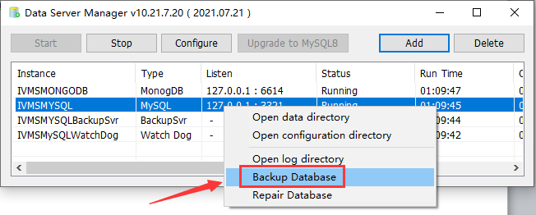
2. You can set it as below picture to backup data, after this, it will backup data to the path you set.
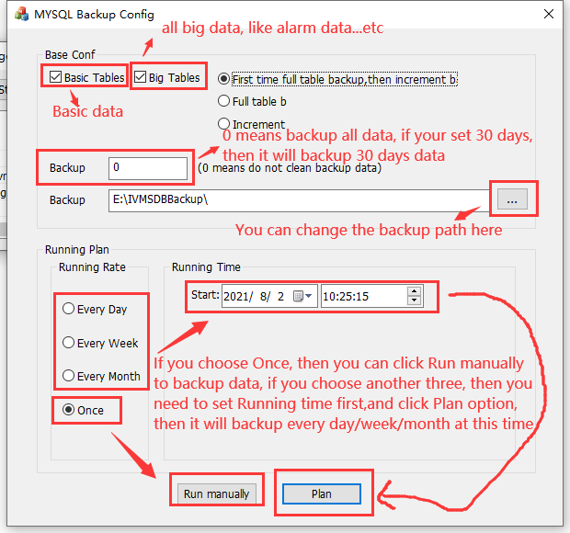
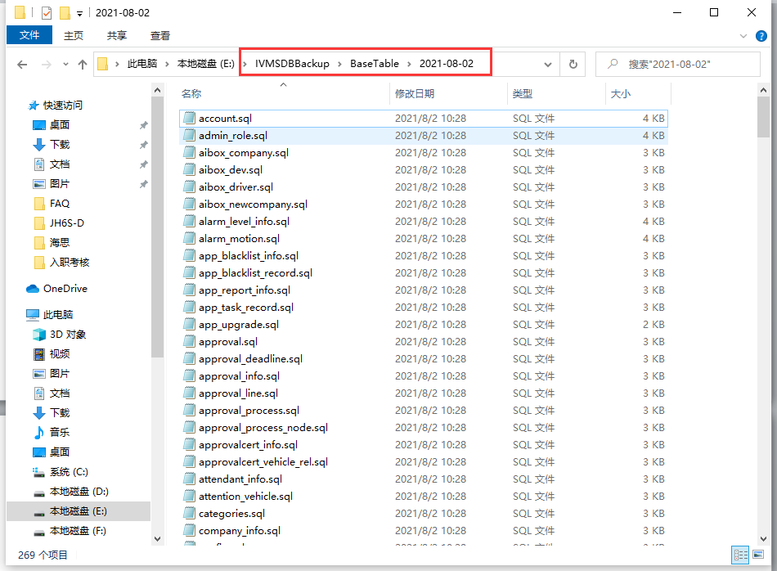

- Restore MySQL data
1. Open the MySQL Server Manager software, then right click IVMSMYSQL service, and choose the Backup Database option.
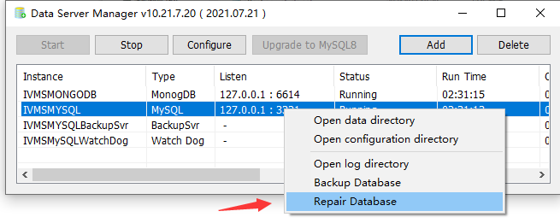
2. Choose the backup folder, and set the big data restore days, always set -1, it means restore all the data.
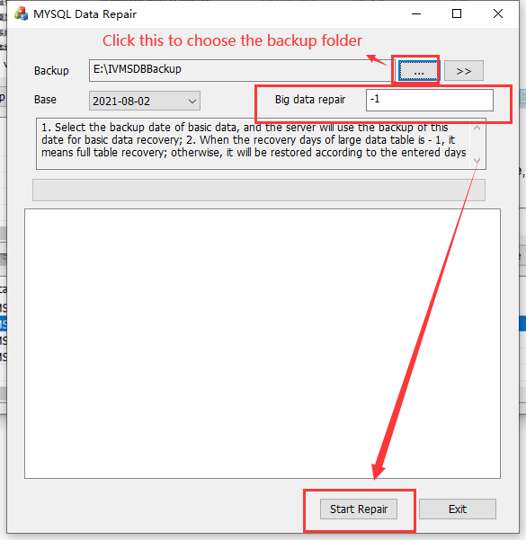
3. After restore finished, it will shows Job finished, then click Data Repair Finish, and restart the IVMS server to check the data is restored or not.
