here are two steps to add the Google Map API.
First, how to get it.

1, You need create a goolge account first.
You can use link: www.google.com

2, Link to below web site and log in with your account.
https://console.developers.google.com/apis/library?project=sacred-pipe-135123&pli=1

3, You need to create a project first and then create a API Key (Server API Key)，and you need to pay for it.
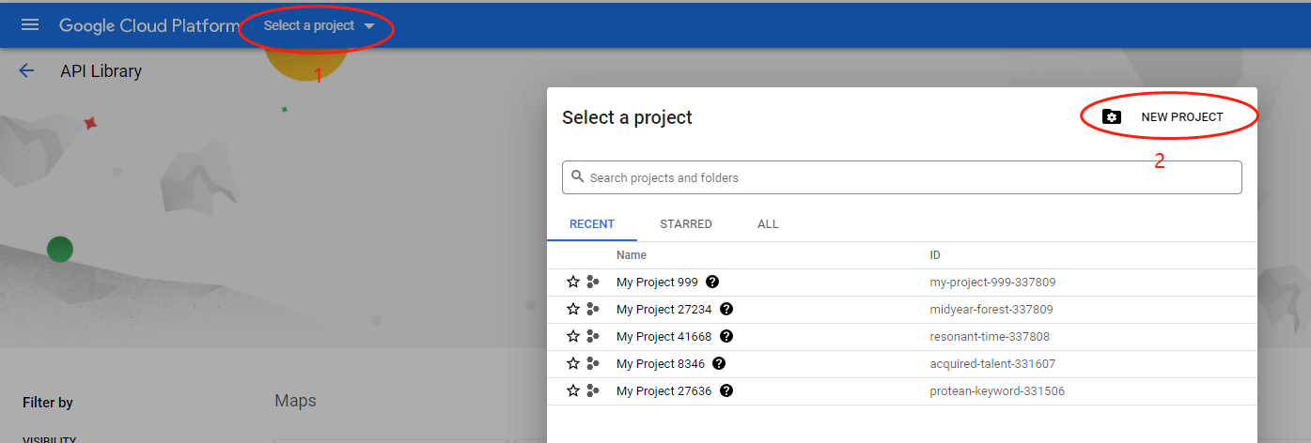

4, Select the “Google Maps JavaScript API ”.
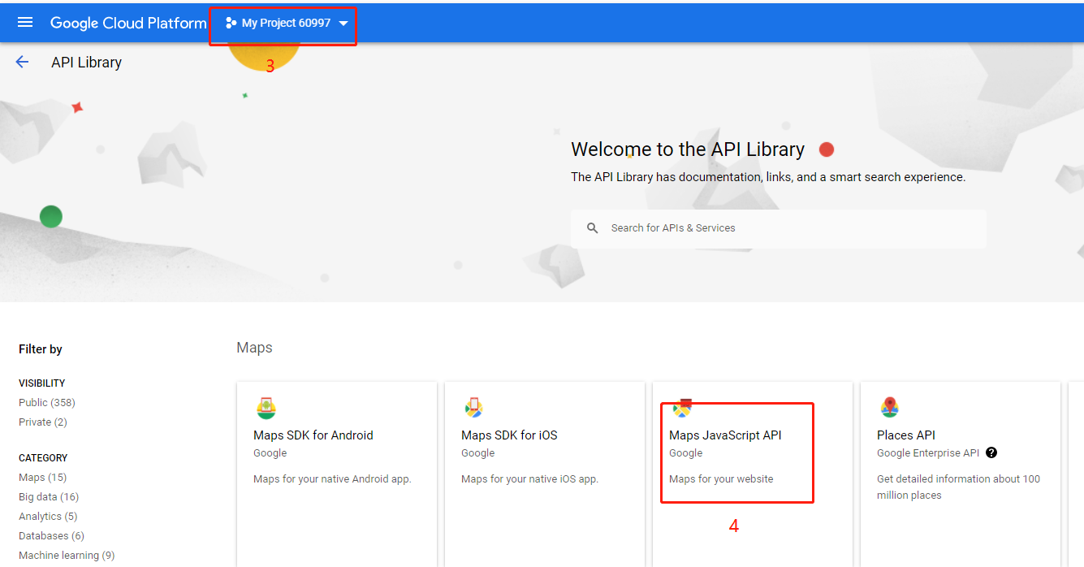

5, Click the Enable button.
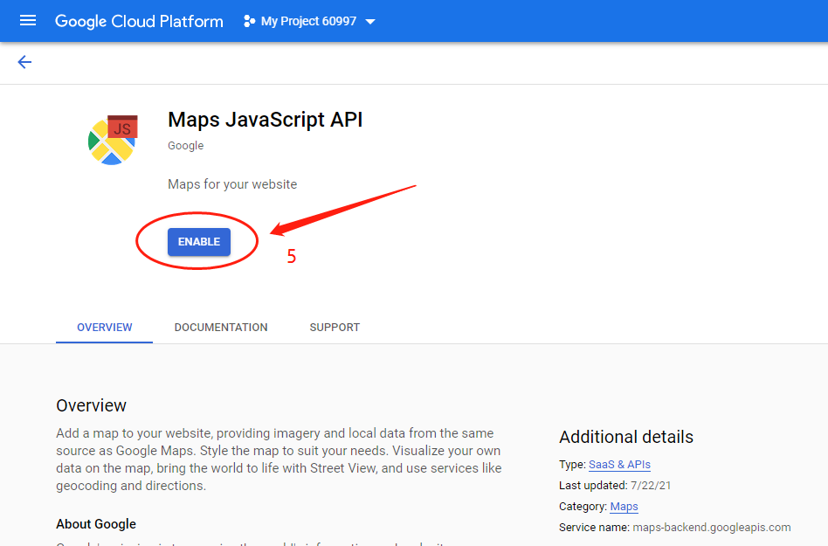

Select the Credentials
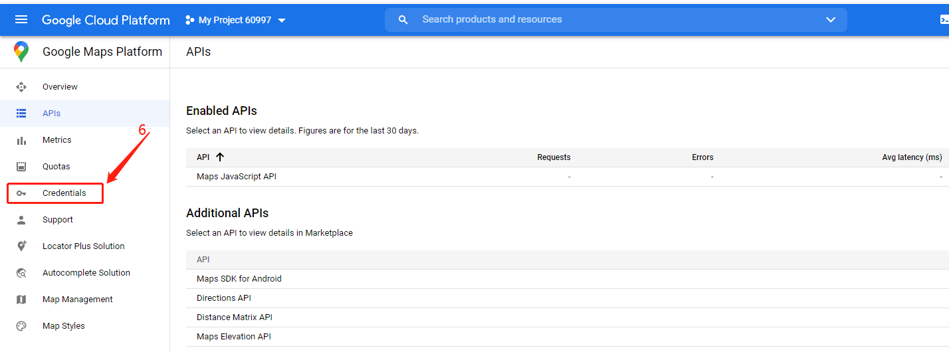
Creat a key
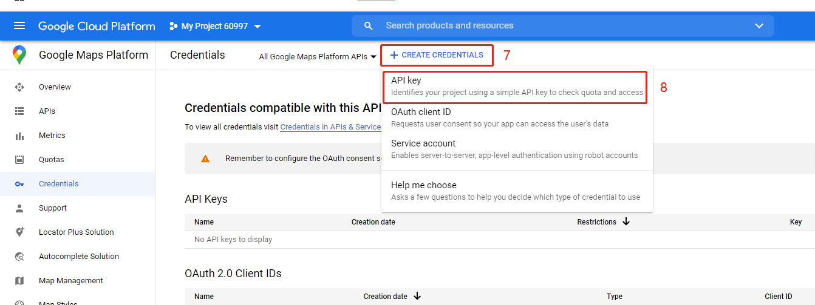
And you can get the key
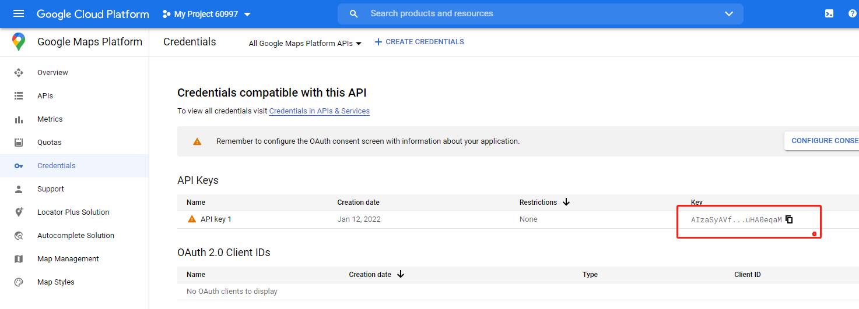

Second, How to add it.

6, Use Note book Open file “gmap.html”
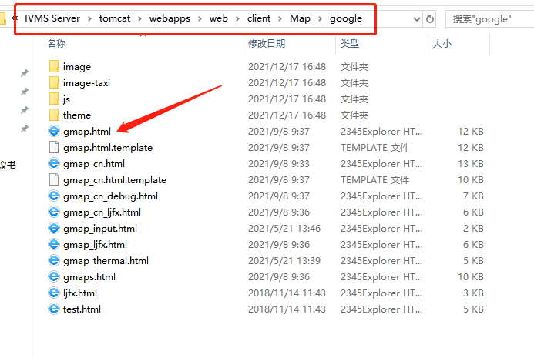

7, To use the following words replace the same line words.
<script type=text/javascript src="http://maps.google.com/maps/api/js?key= (your API key) &sensor=false&libraries=places" charset="utf-8"></script>

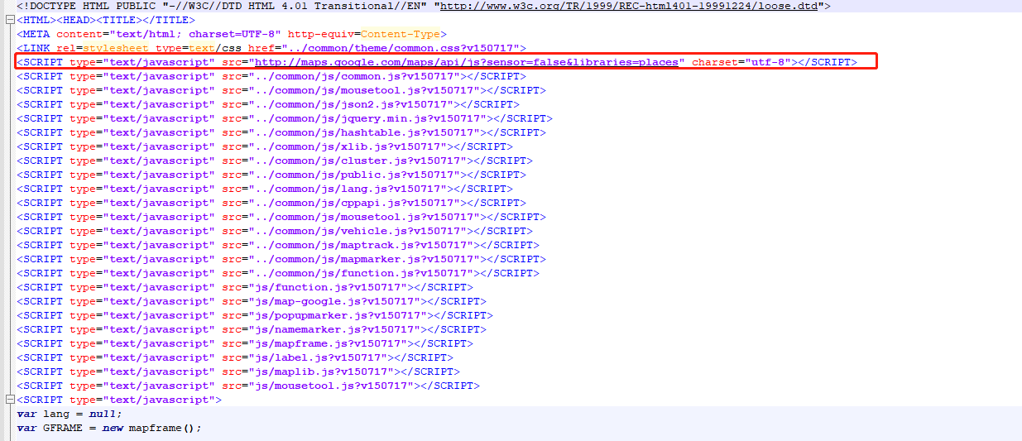

8, Restart IVMS Server.

