How to set overtime Parking Alarm
1. Before test this function, need add the device and client, and need make MDVR online(wifi online or 3G/4G online), you can refer to the following link.

https://www.icarvisions.com/faq/how-to-use-3g-4g-online-for-mobile-dvr-227.html
https://www.icarvisions.com/faq/how-to-get-mobile-dvr-wifi-online-241.html

2. First, need set the alarm parameters on the MDVR, like the following.

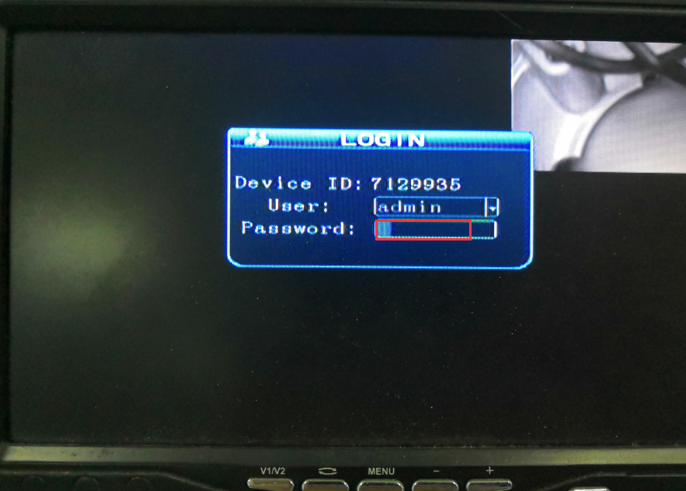

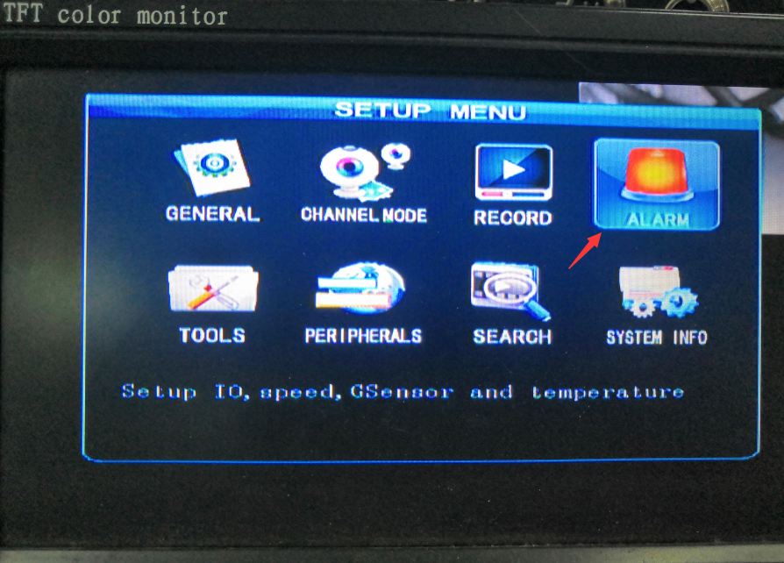

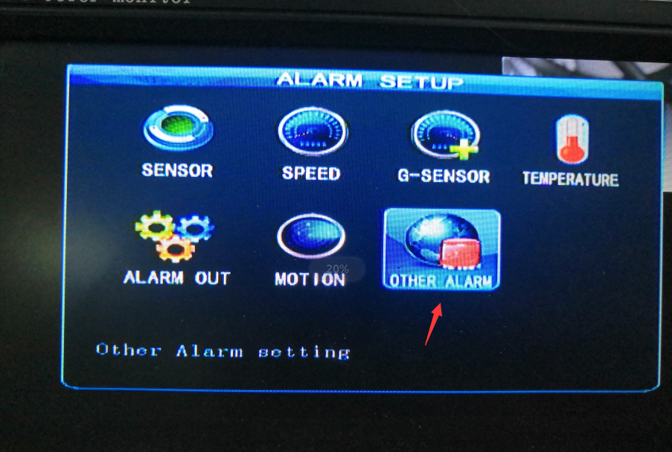

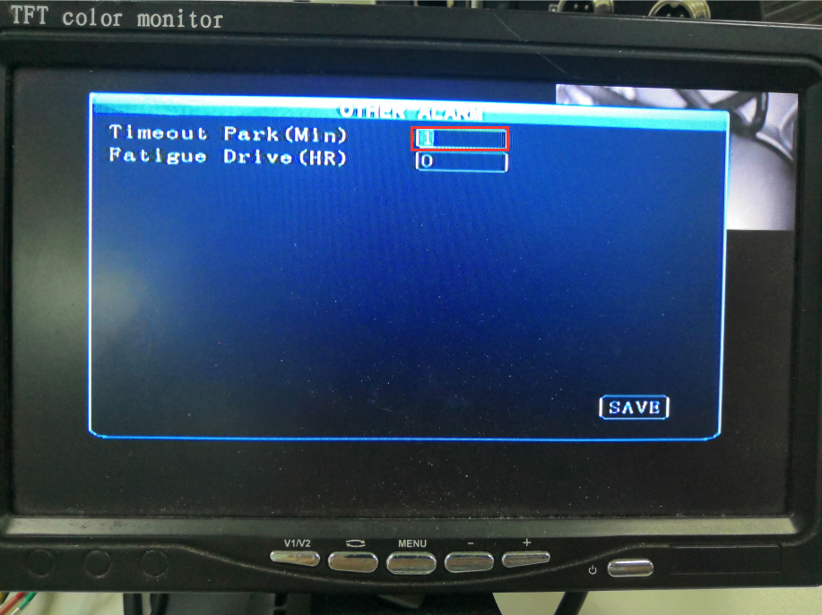

3. Login the PC client, and check if the device is online.

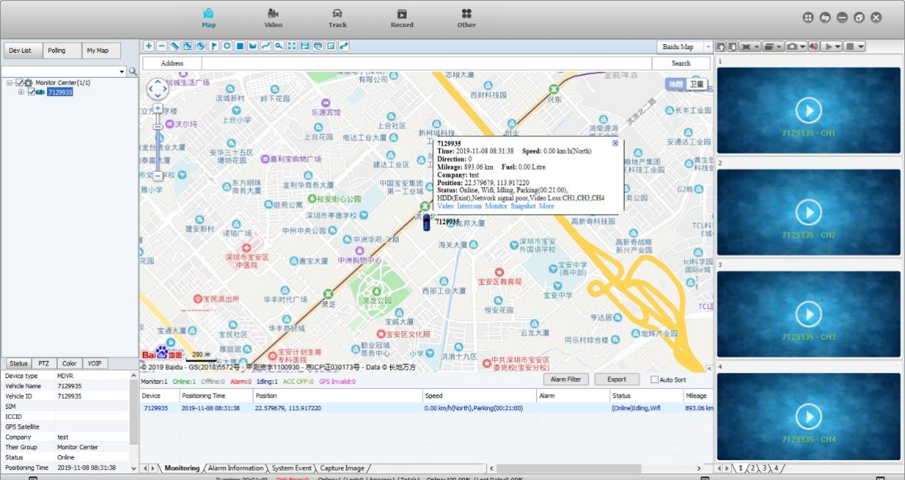
Old Web
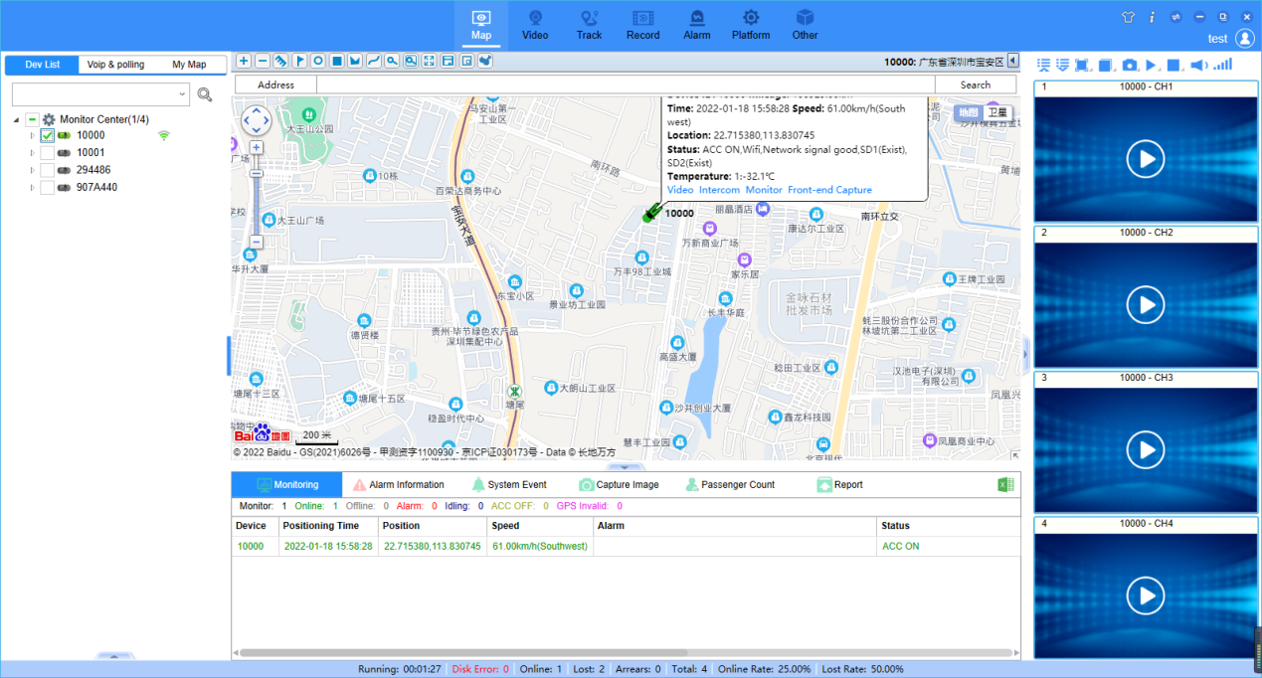
New Web

4. Then the next step is to trigger the alarm, normally, when the car is parking, the ACC should be off, so you can make the ACC off, and wait one minute. And then see the alarm.

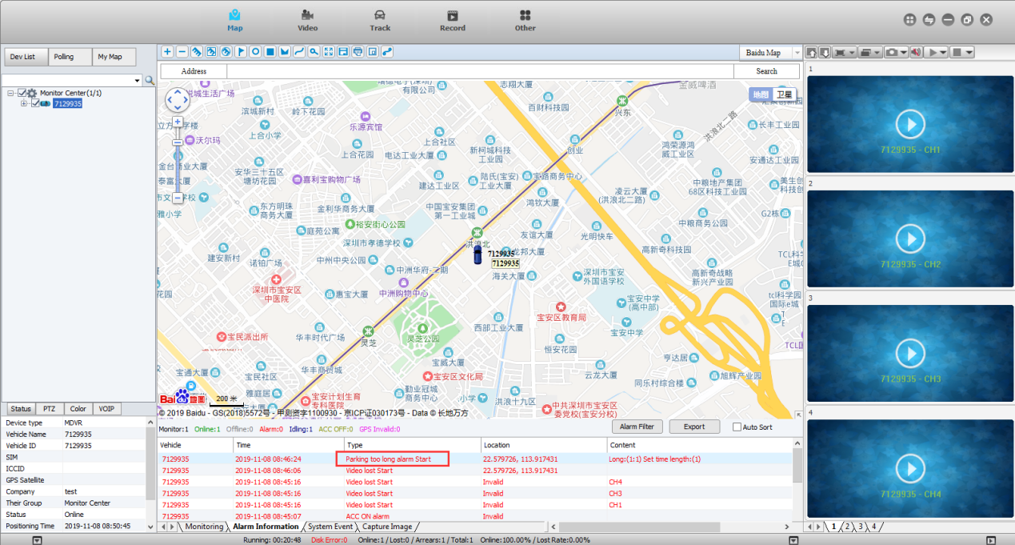
Old Web
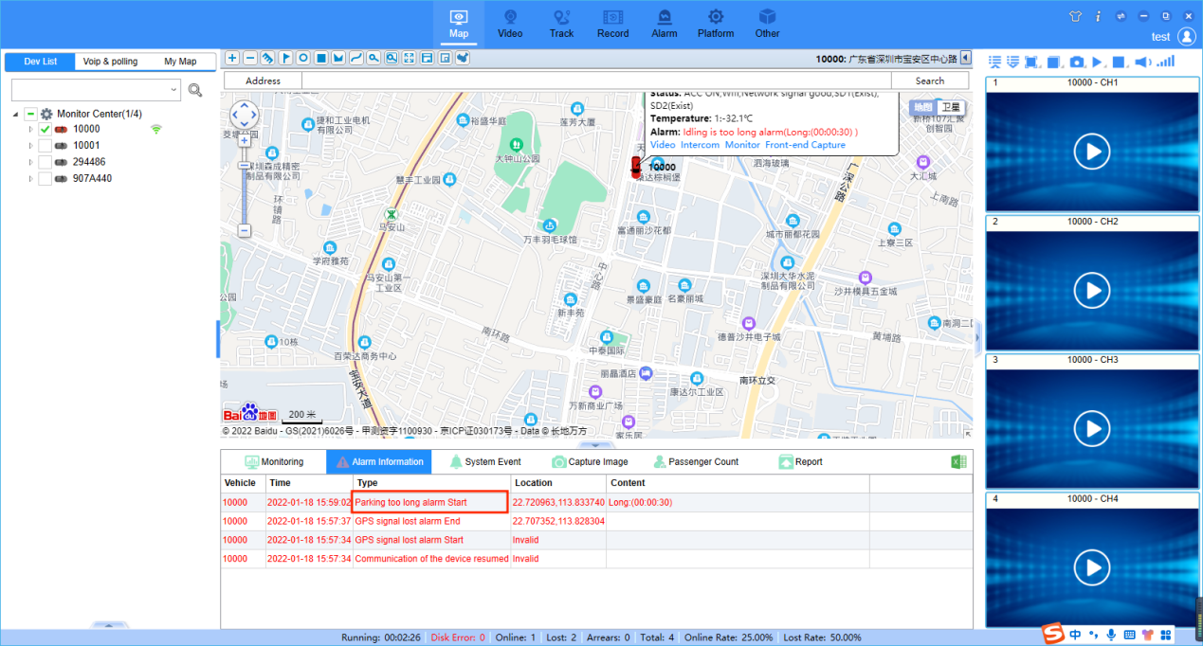
New Web

