How to Set Record Plan
1.Use admin login the web, enter the “Servers” page to add device to Storage Server.

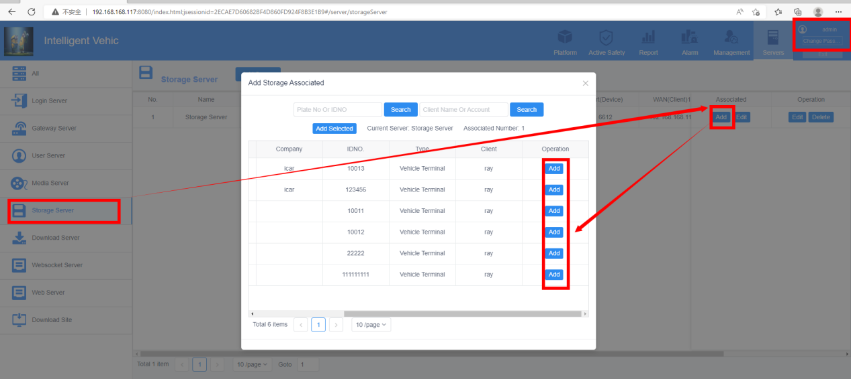

- Use the account which contains the device you add to storage server login the web, then enter “Platform” page to set the record plan.
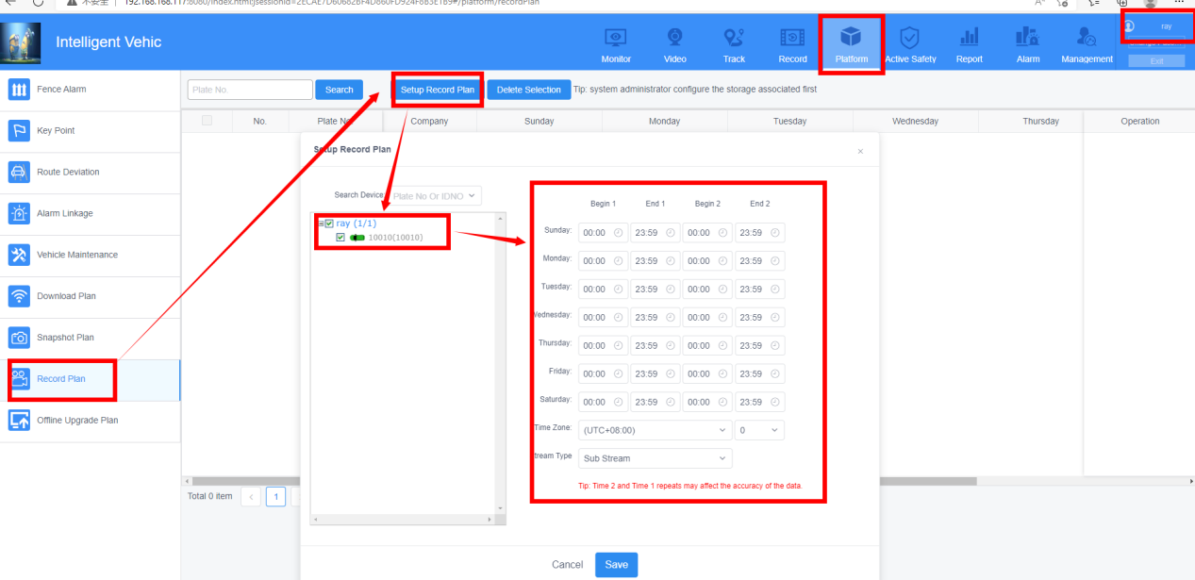

- Modify packaged video length and The store path.
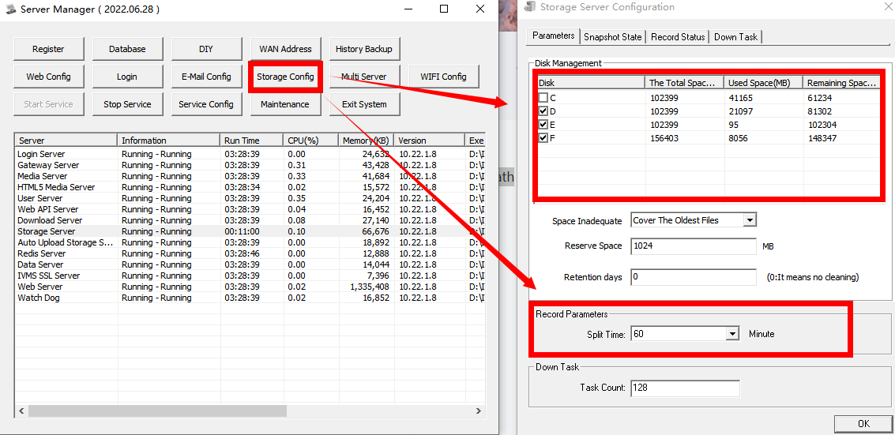

- Restart the Storage Server and check whether there are file on Record Status .
