How to change the Device Num from New IVMS Client Side
- First, close the New IVMS Client.

- Second, open the IVMS Client installation directory, find the ivmsCfg.xml file.

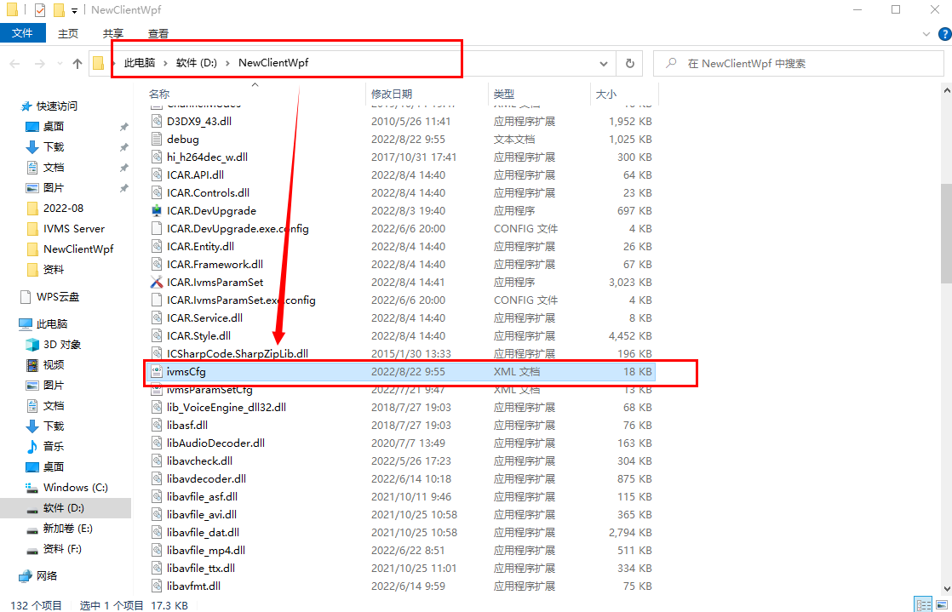

- Open the ivmsCfg.xml file , find the configuration item enableEditDevId to change the 0 to 1, and save it.

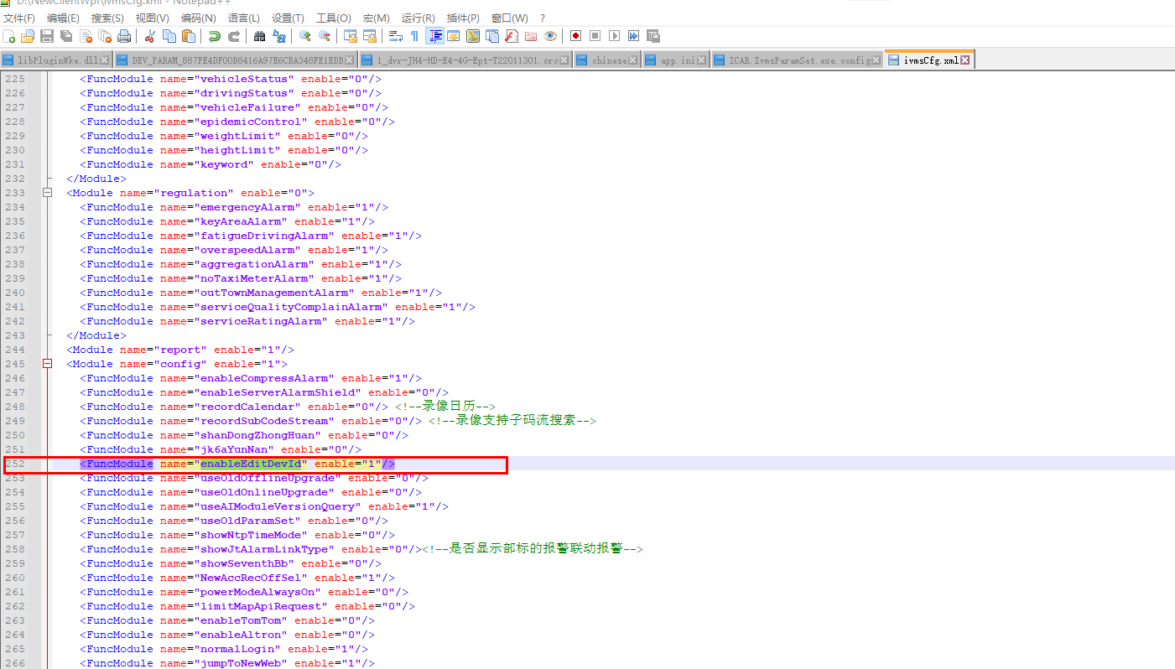

- Restart the IVMS Client, then you will find change Device Num function in the Parameter configuration.
