Analog Intercom User Manual
- Analog intercom wiring
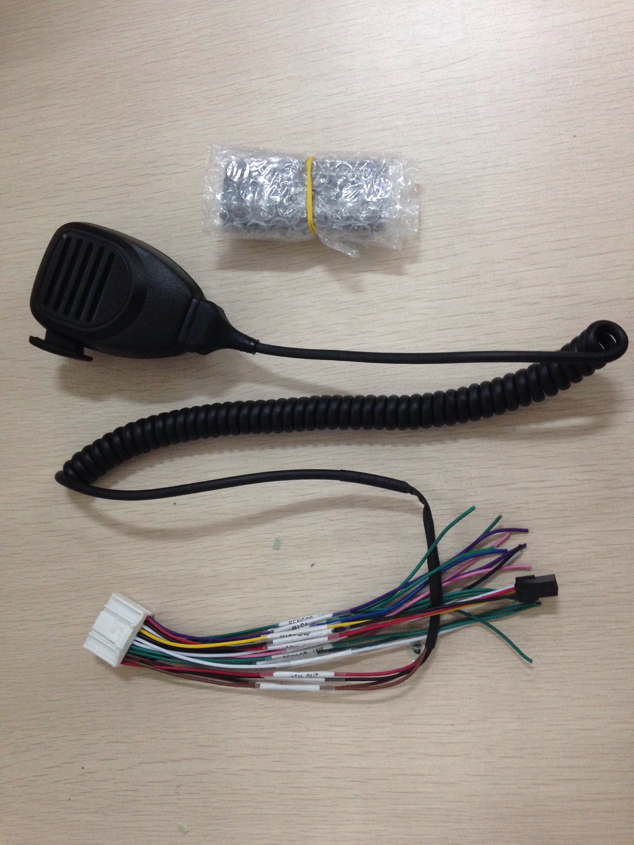
6 Pin analog intercom
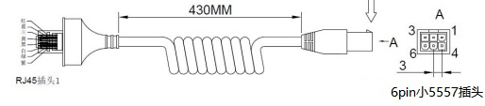
Analog intercom port | MDVR 24PIN port
1 | A-OUT
4 | 12V
3 | GND
2 | A-IN
Note: Under normal circumstances, the analog intercom interface can be directly connected to the 24PIN interface.

- Connect analog intercom
Log in to the IVMS client and select Voice Intercom to open. Select device and start talk.
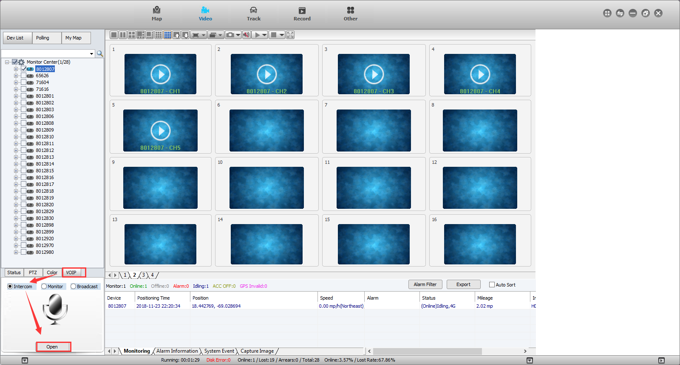
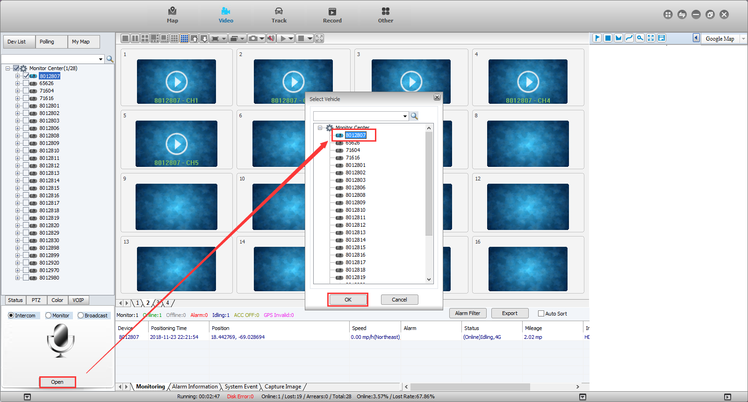
Old Web
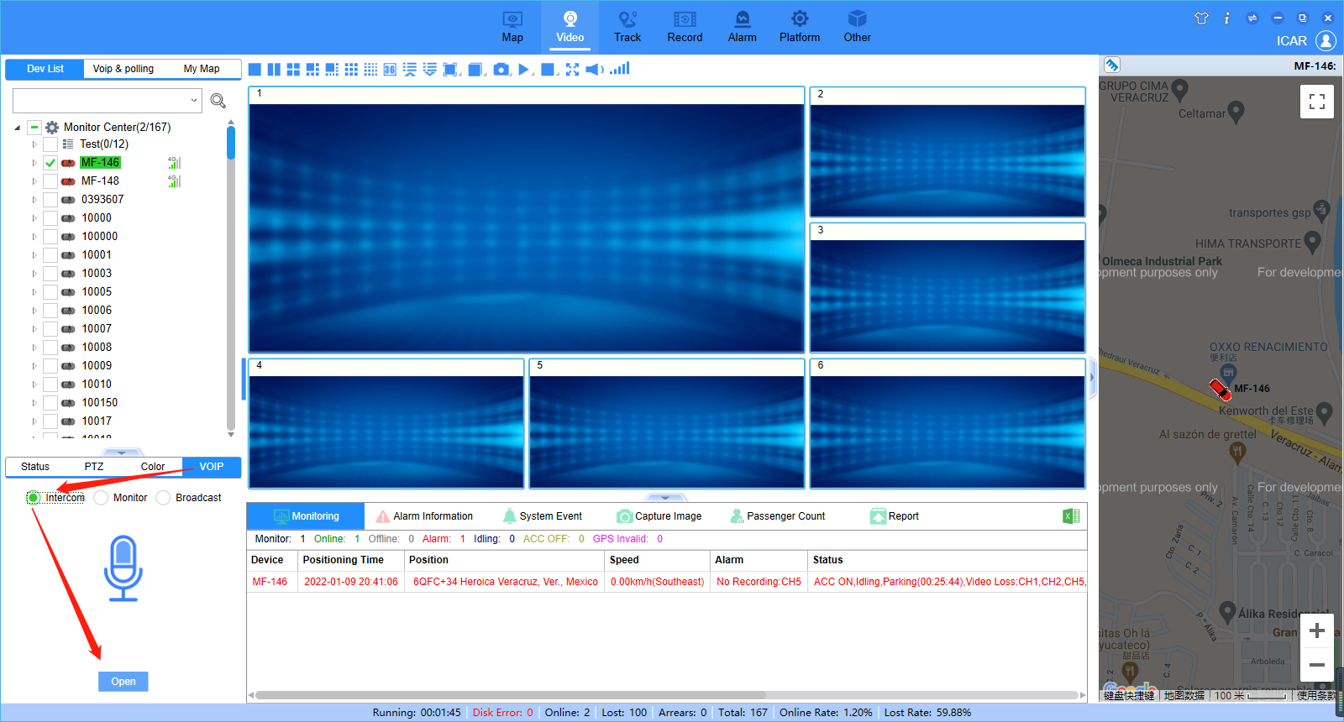
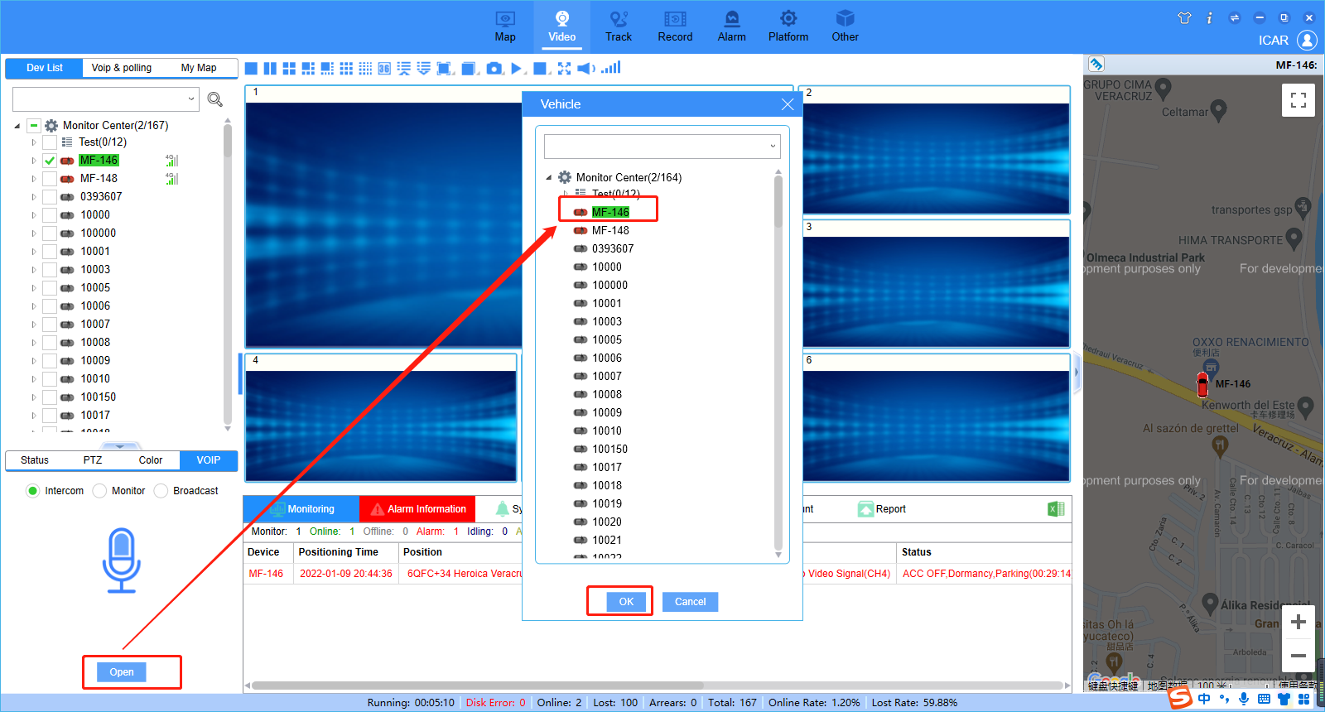
New Web

