How to slove that after reninstall mysql server and Server Manager connect DB Falied

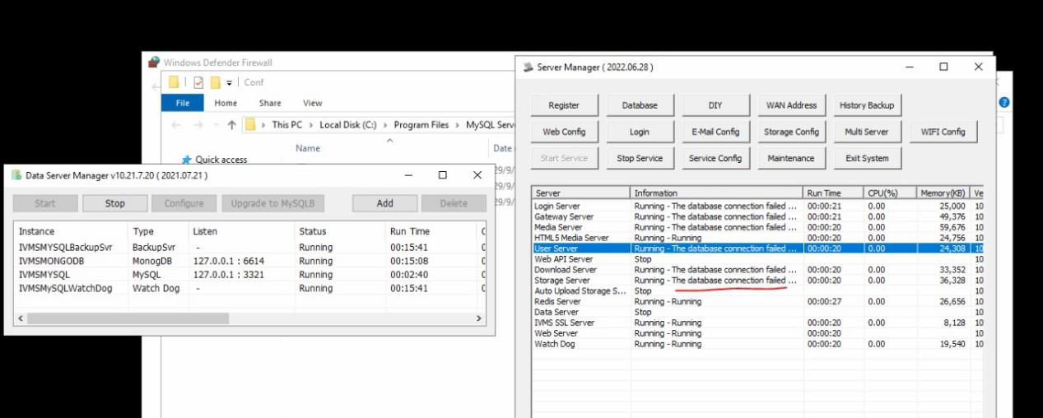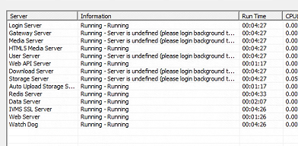
The cause of this problem above pictures is that DB checker is not executed correctly.

- First, you should backup your mysql data.
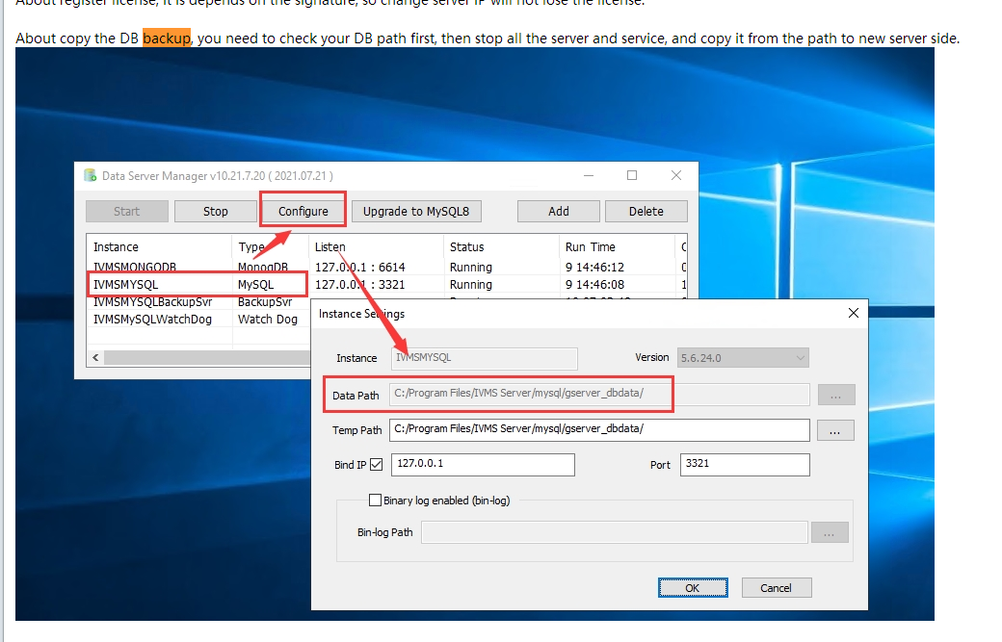
- Stop follow server and add a new mysql server .
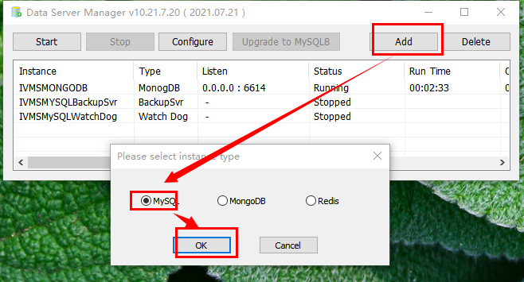
- Select correct mysql version, the Version should be same with older version, select mysql backup file path in step 1 as Data Path.
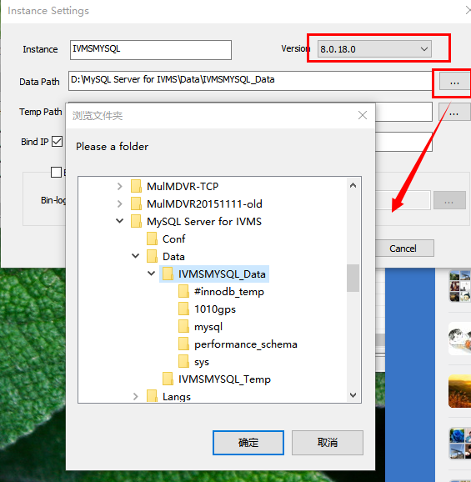

Note:
the default data path for old server is ……\IVMS Server\mysql\gserver_dbdata
the default data path for new server is ……\MySQL Server for IVMS\Data\IVMSMYSQL_Data
- And then, open ivmssvrwizard.exe.
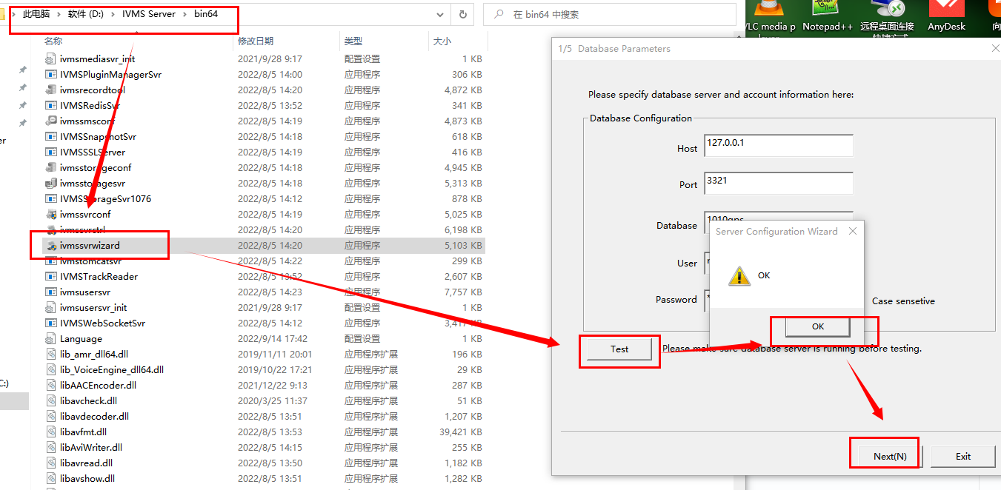
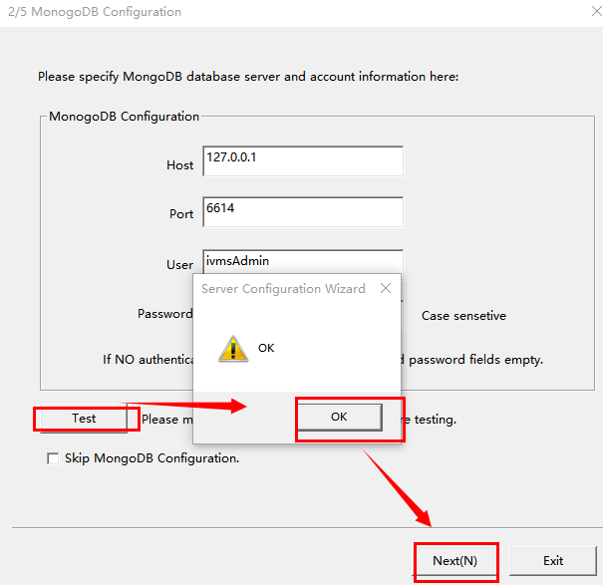
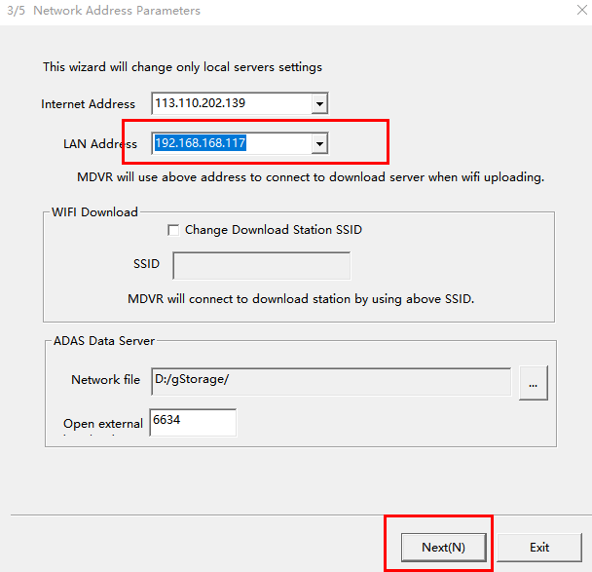
- The last step is DB checker, after show success and start the server program,it will be running normal.
