How to setup Complex password function
- Open file webClient.properties.
Path:xxx:\IVMS Server\tomcat\webapps\web\WEB-INF\classes\resource
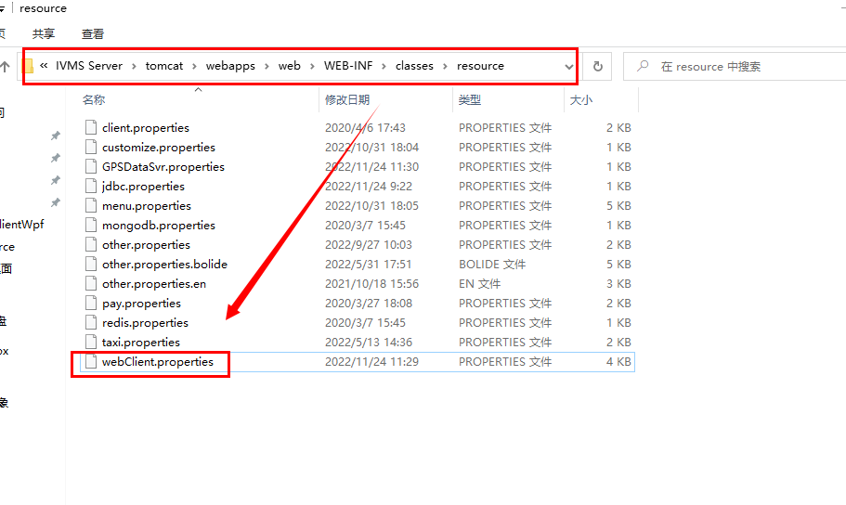
- Change isSecureLogin=false to ture and save.
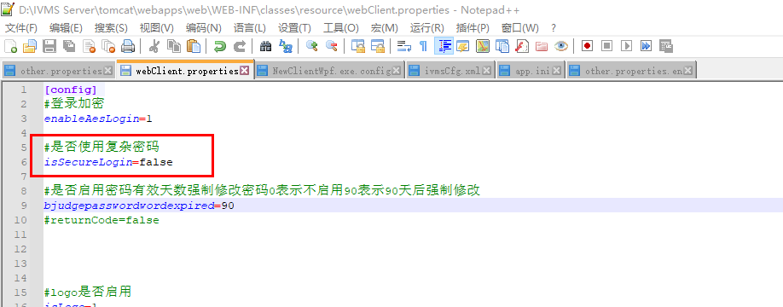
- Restart the web server.
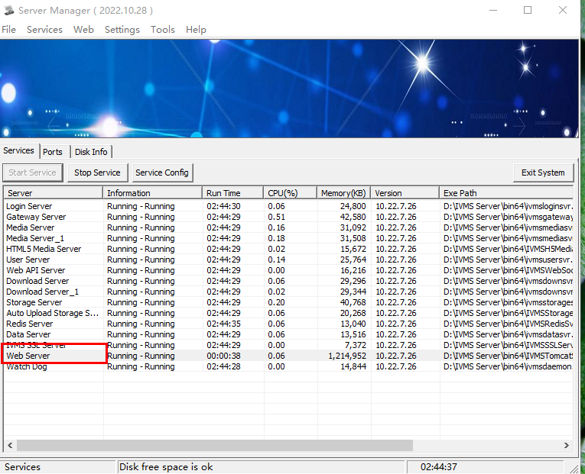
- After that , you can login in web and change password to check.
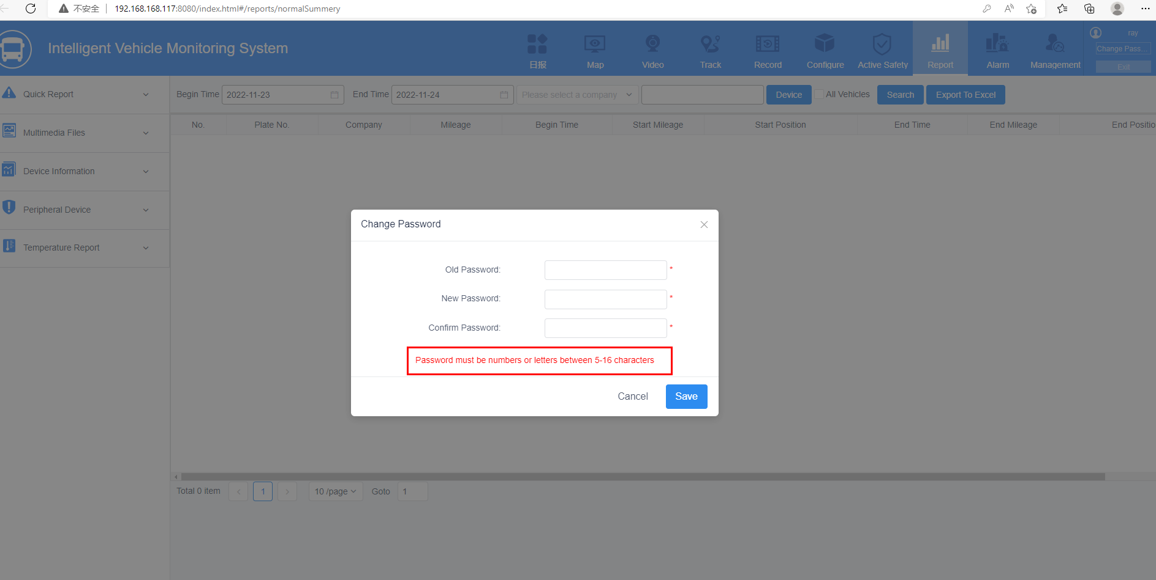
Before
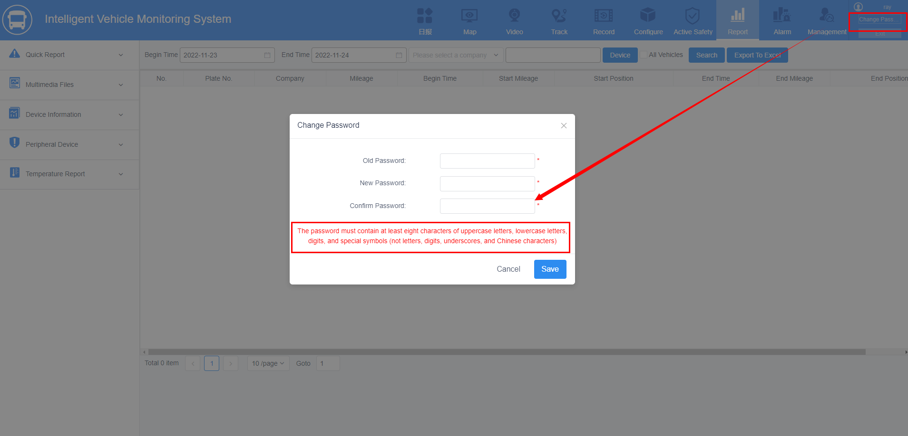
Now

