How to solve the web client Google map can not work

Since the Google map API key we added to Google map side was overdue, the Google map will not work at our web client side, and it will show like this, if your server already had this issue, you can follow this to solve it.
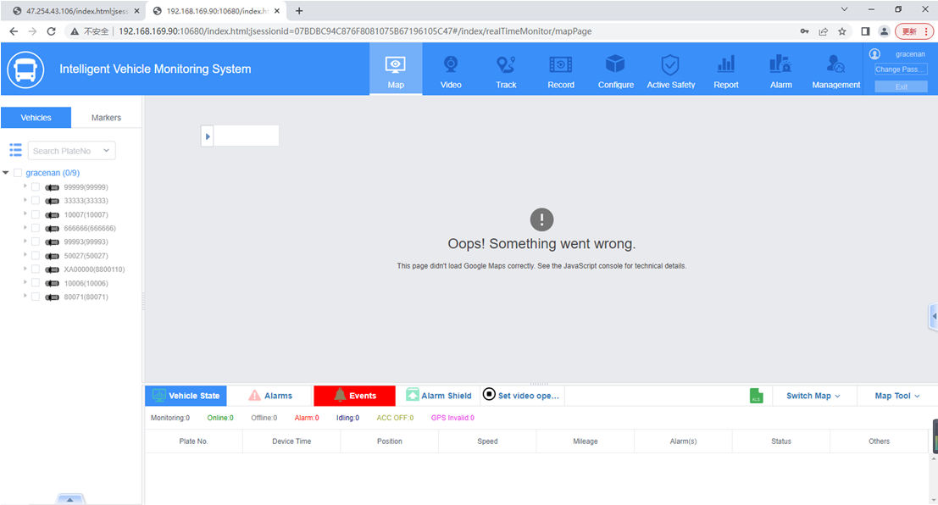

1. Stop the web server at server panel side, then open the IVMS Server installation path, find the index.html file.
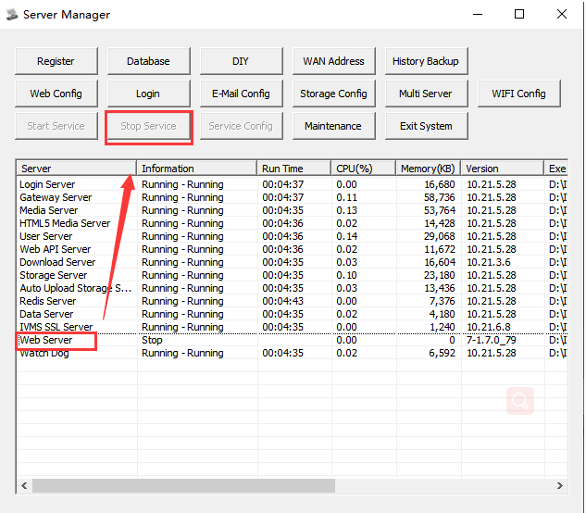
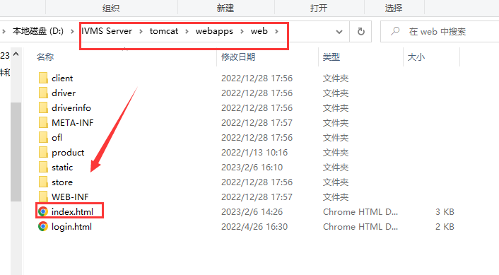

2. Open index.html to add this code and your Google map API key under the last line, see below:
Such as:
<script type="text/javascript" src="https://maps.googleapis.com/maps/api/js?key= &callback=initMap" async defer></script>
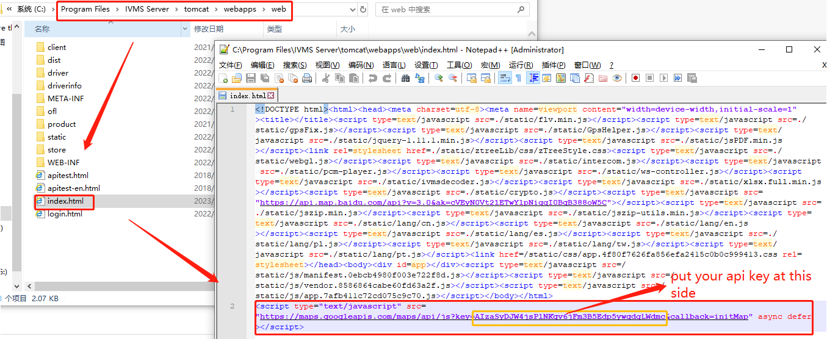

3. Restart the web server and check the web client again, then you will see the Google map is working.
