SMS Push Settings
- Open the cloud.properties file and modify the parameters to open the SMS push function and select the SMS type you want to send. The following picture shows the parameters to open the AWS SMS type.
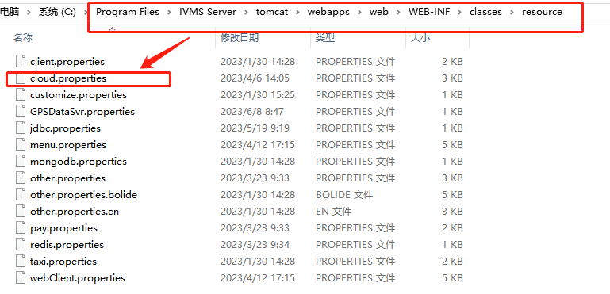
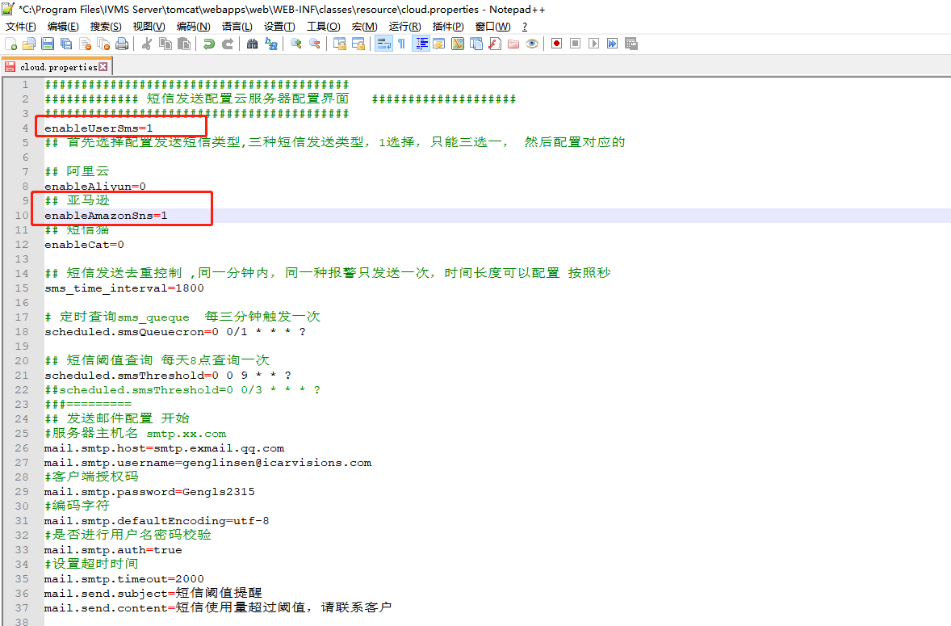
And fill in the SNS Key of AWS.(SNS Key can be purchased by yourself or by contacting the sales.)
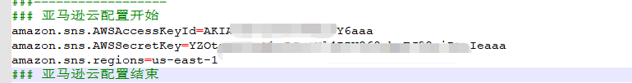

- Log in to the admin account and create a sub-account.
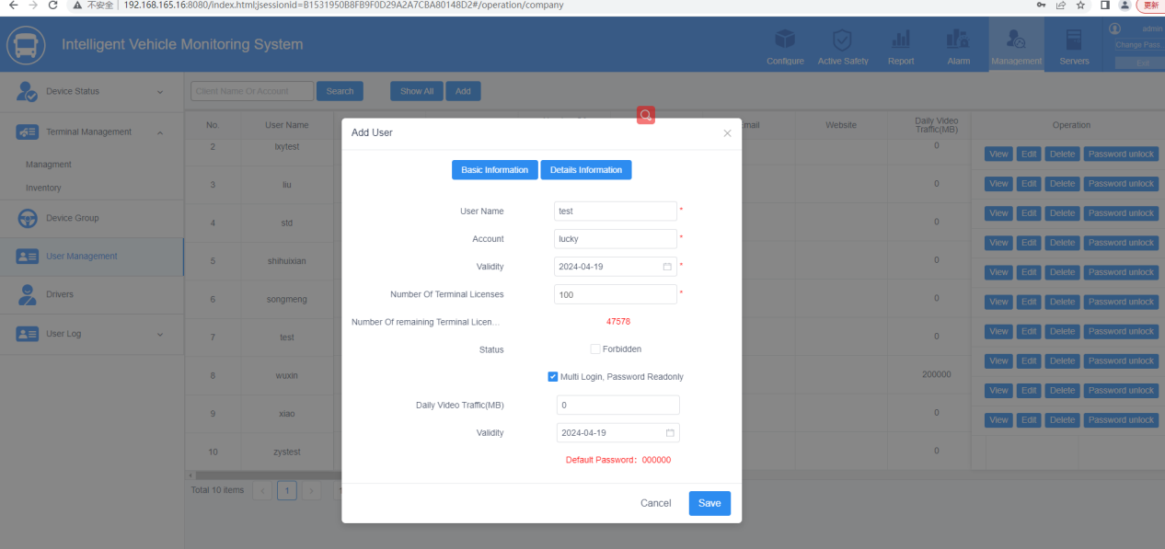

- Configure alarm linkage.
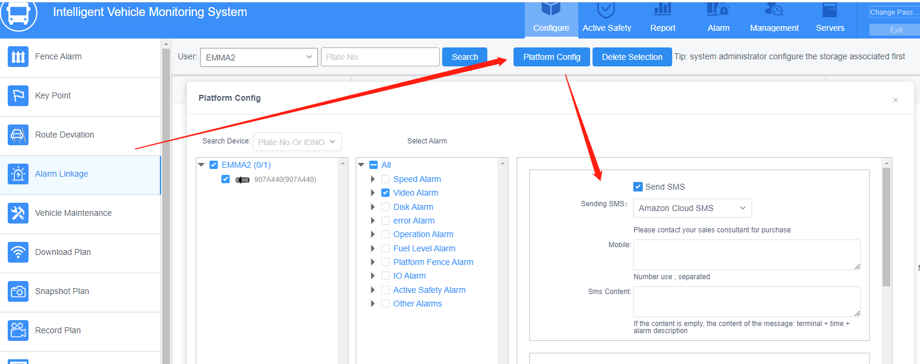

- Allocate the number of SMS messages that can be sent from this account.
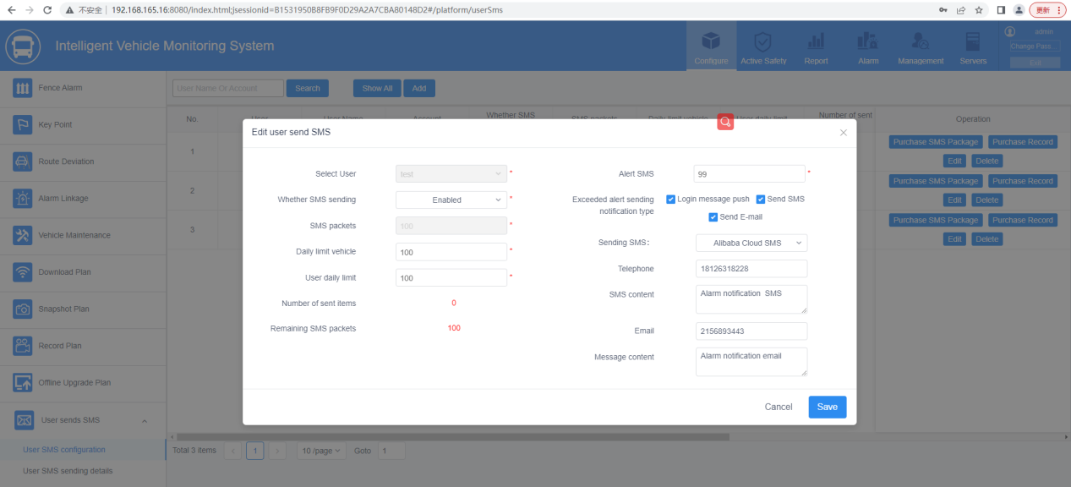

Note:
- 'select user' can not be edited after filling in the user.
- Each car and each user is limited, exceeding the limit will not send SMS again.
- Alert SMS, below the set threshold will be recorded SMS threshold.
- Notification type, there are login message, email, SMS push three types.
- SMS type support SMS cat, Ali cloud, Amazon.
- SMS input box support 32 characters, mail input box support 64 characters, exceeding the limit can not be entered.

- The higher level account can assign the number of SMS available to the lower level account, but the lower level account needs to have the privilege to send SMS.
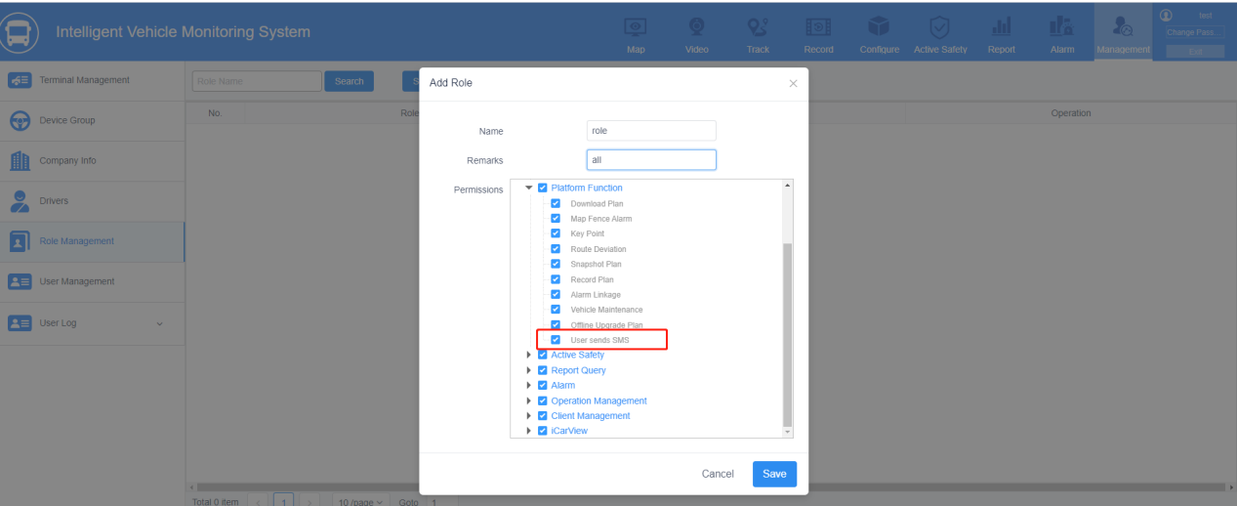

- Login a high-level account can be assigned the number of SMS available to low-level accounts by adding the User SMS configuration (do not enter more than the number of available SMS). The number of available SMS can also be assigned by purchasing SMS and the purchase will be recorded.
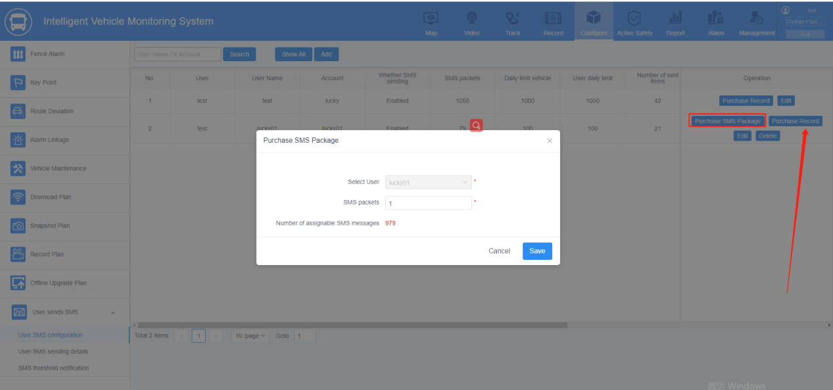

- This report can query the records of SMS sent after the alarm had triggered.
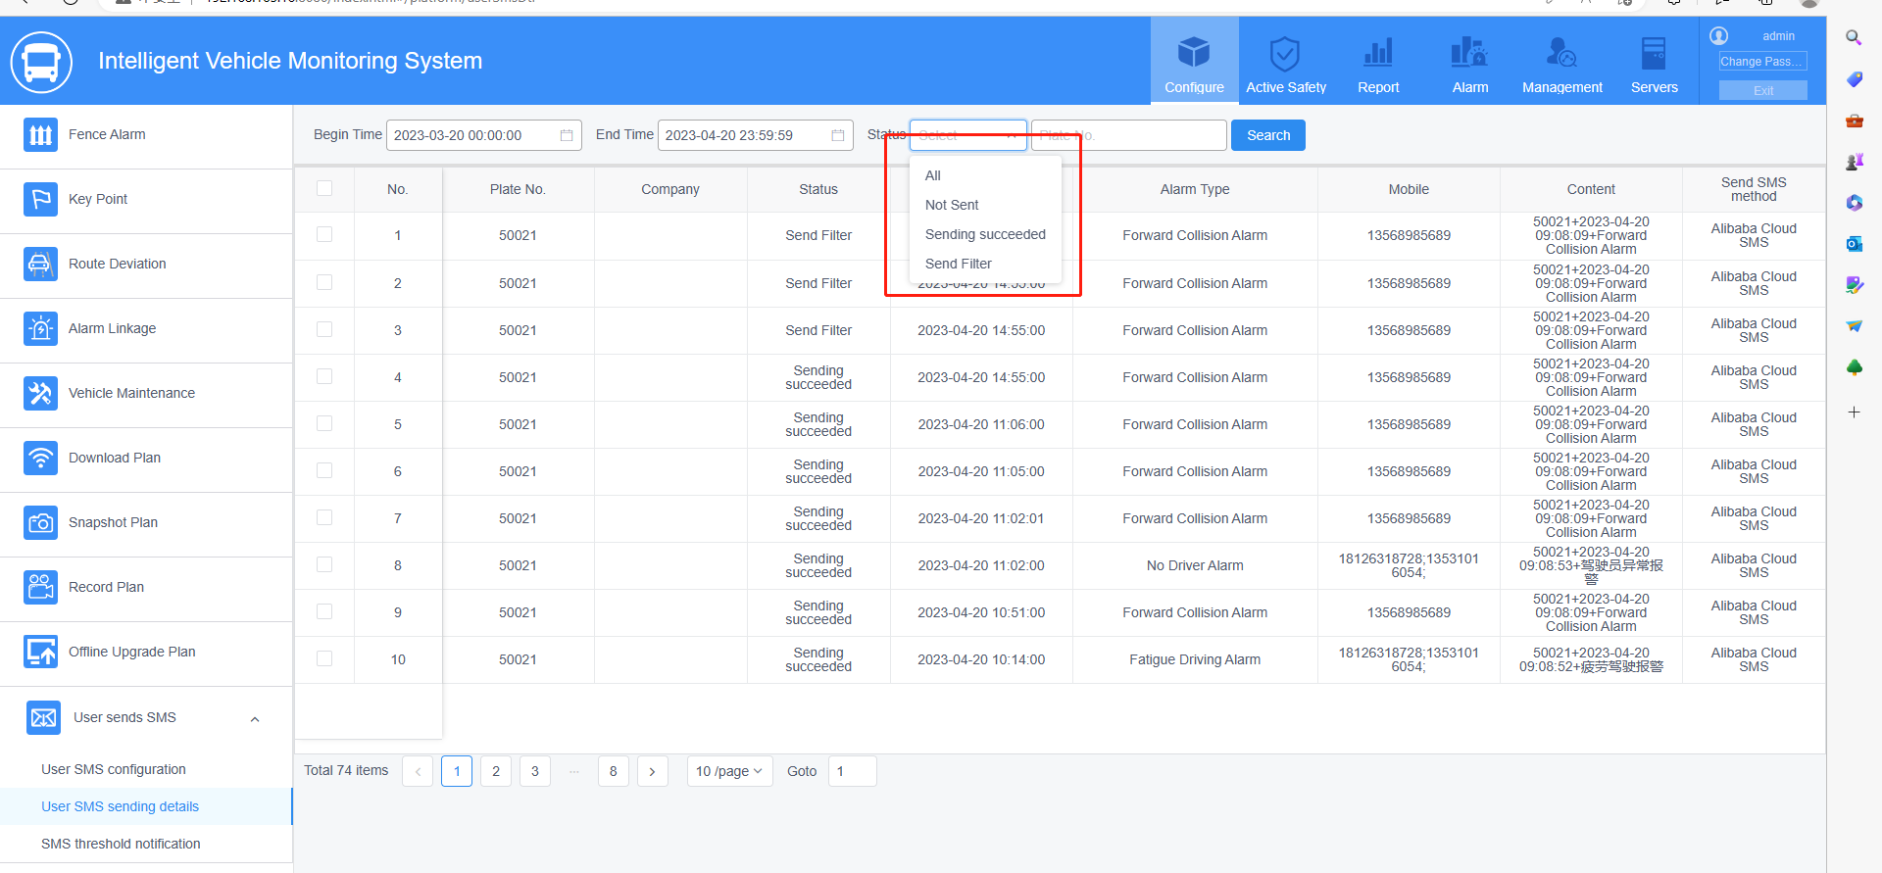

- SMS de-duplication, the same alarm will only send SMS once in a period of time. The default de-duplication time is 1800 seconds, which can be modified by yourself. If the device is abnormal, the alarm is triggered continuously, or the same type of alarm is triggered continuously, the SMS will not be sent, but the record can be checked inside the filtering status.
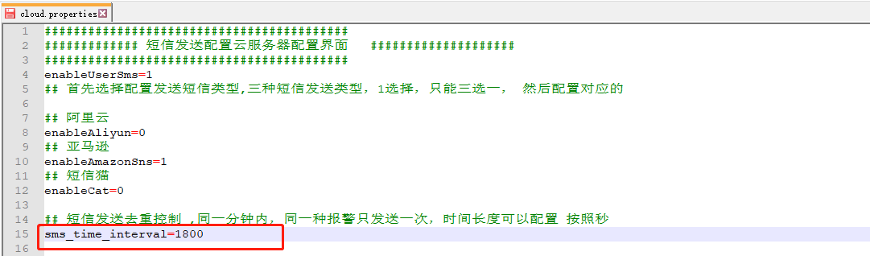
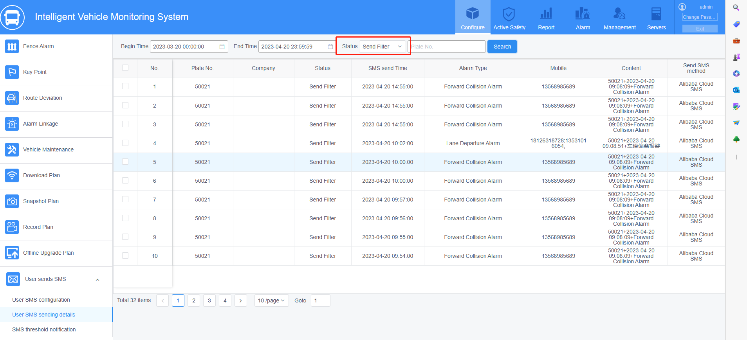

- After lower than the SMS threshold, there will be a record of the notification types that have been checked.
