How to Register License for IVMS Server
- Find WAN Address on the manager of the IVMS server and open it to view the IP address of the server.
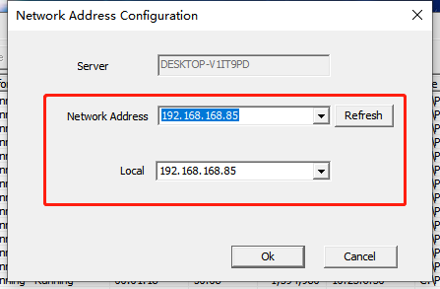
- Copying the IVMS server's Signature.
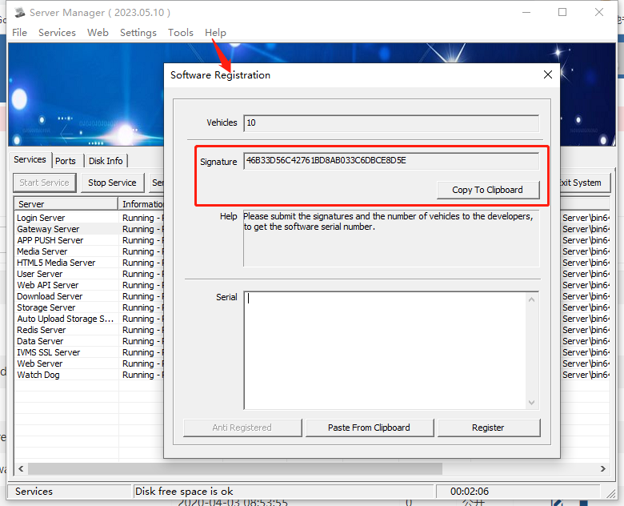
New Server
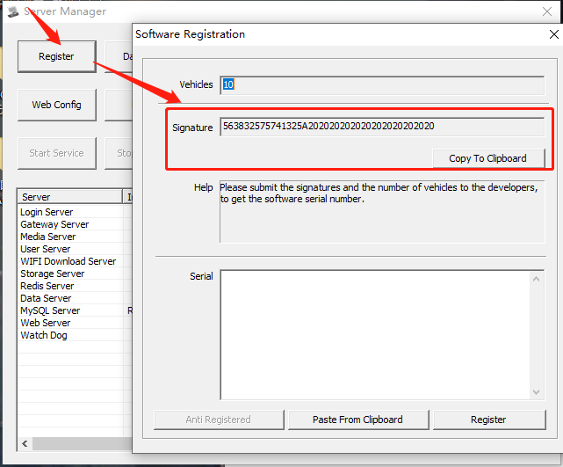
Old Server
- Then you can send an email to our sales/technician to register the licenses, which need to include: the IP address of the server, the signature, and the number of licenses to be registered.
- Once the sales/technician receives the email, they will apply for licenses based on the information you provide, please make sure the information provided is accurate. Finally you will receive an email containing licenses, fill in the licenses in the registration interface of IVMS server and click register, the number of vehicles will be increased. If there are any questions, please contact technical support.
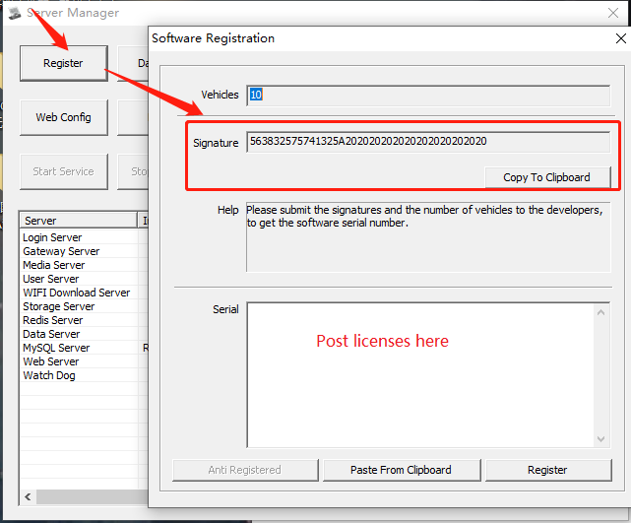
New Server

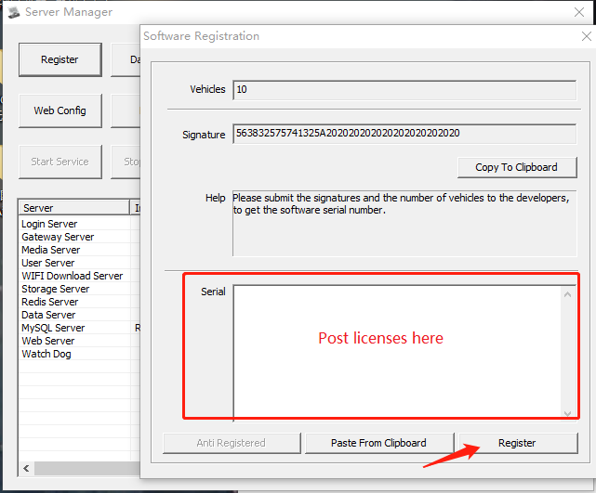
Old Server

