How to solve the Google map not working show blank at IVMS Player side
1. The Google Map shows a blank screen on IVMS Player, see below:
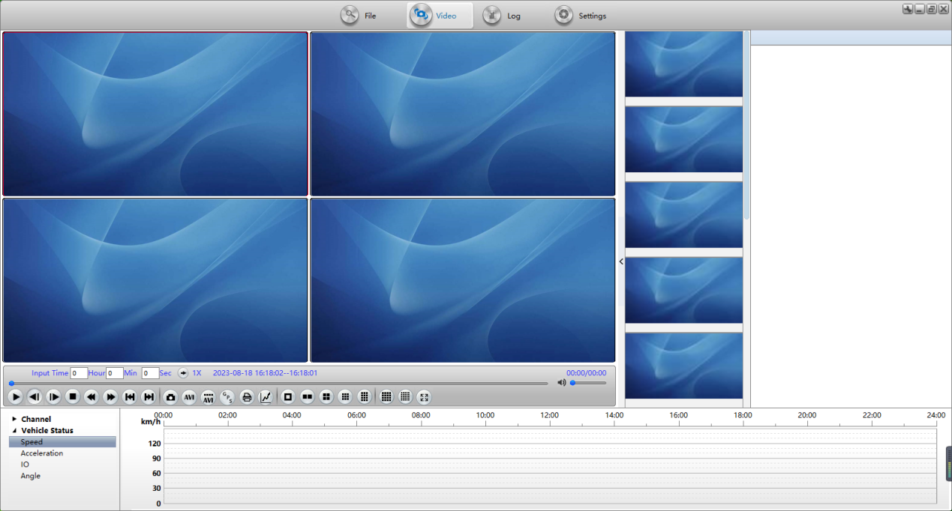

2. Since Google Maps has changed its policy to no longer support older chromium versions. Our previous chromium version was too old, and we need to update a new chromium version.

3. Because of this, our engineer had found a temporary solutionto fix it. You can delete the cef folder and replace new cef folder to this path：
Path：...\IVMSPlayer\plugin\browser
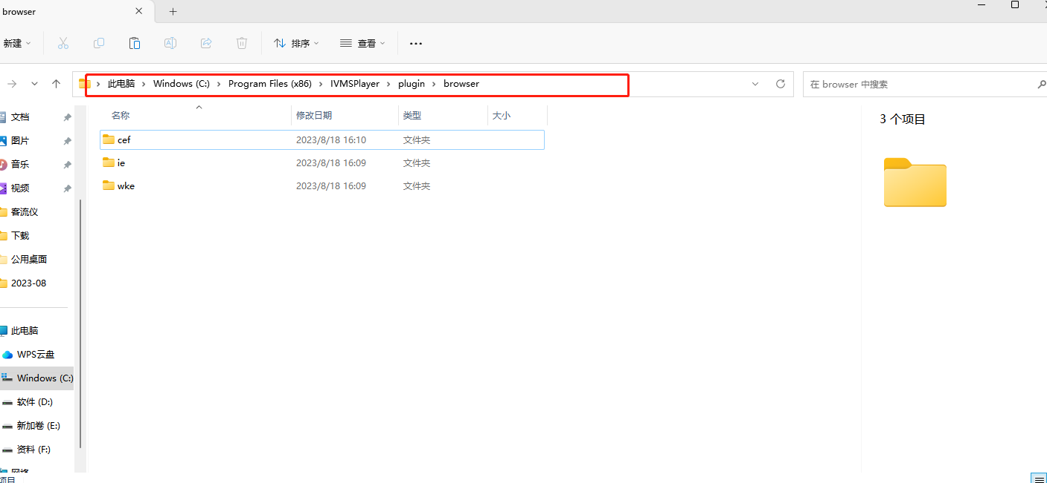
The new cef folder download link as below:
https://www.dropbox.com/scl/fi/j1lzjdk78f9avzxc0ms2q/cef-v115.3.15-win64.zip?rlkey=5cuqnbuixg186ounoartzl52z&dl=0

4. After replaced all the files inside cef folder, restart the IVMS Player, then you will see Google Maps work normally.
