How to solve the Google map not working show blank at IVMS Client side
1. The Google Map shows a blank screen on IVMS client, see below:
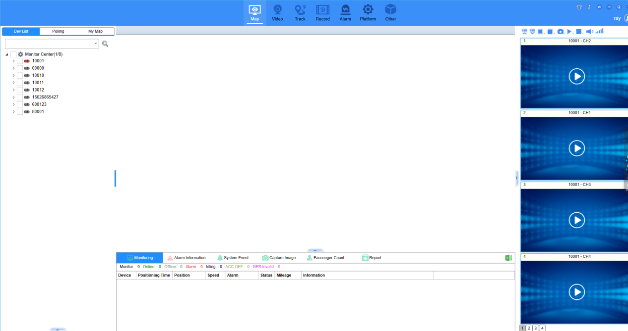

2. Since Google Maps has changed its policy to no longer support older chromium versions. Our previous chromium version was too old, and we need to update a new chromium version.

3. Because of this, our engineer had found a temporary solutionto fix it. You can copy all the file inside the cef folder and replace it to thie path:
Path：...\NewClientWpf\plugin\browser\cef

The new cef folder download link as below:
https://www.dropbox.com/scl/fi/5533vhkzpksz5jfvhqy26/cef-v115.3.15-win32.zip?rlkey=ye8p77ichr63gpjl71k5g4nko&dl=0

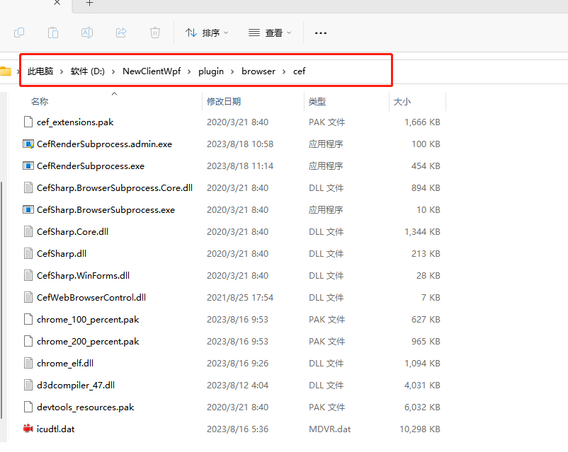

4. After replaced all the files inside cef folder, restart the IVMS Client, then you will see Google Maps work normally.