How to add Google Map API for the IVMS Server
Due to upgrades in the new version server, the location of the Google Map API Key has changed. (NOTE: March 2023 and later versions)

- Use Note book Open file ‘gmap.html’.
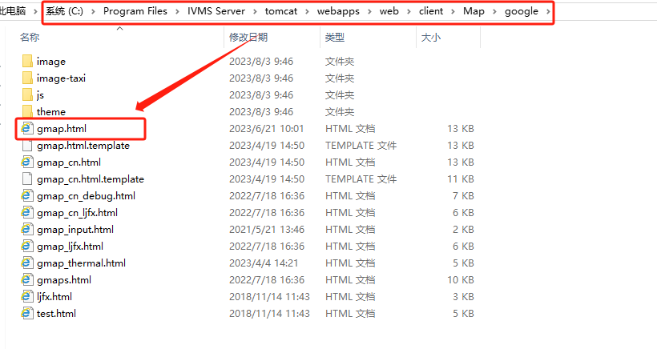

- To use the following words replace the same line words.
var gmapURL = "https://maps.google.com/maps/api/js?key=(your Google Map API)
&sensor=false&libraries=places";
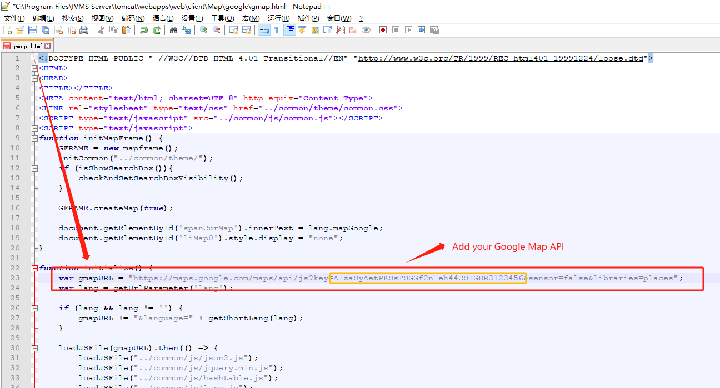

3. Restart the web server.
