How to use the Face recognition function
1. First, you need to make sure your firmware support face recognition function, and your MDVR had already activated the DSM algorithm.

2. Open the web client and login your account, click Mangement---Drivers to add the driver photo.
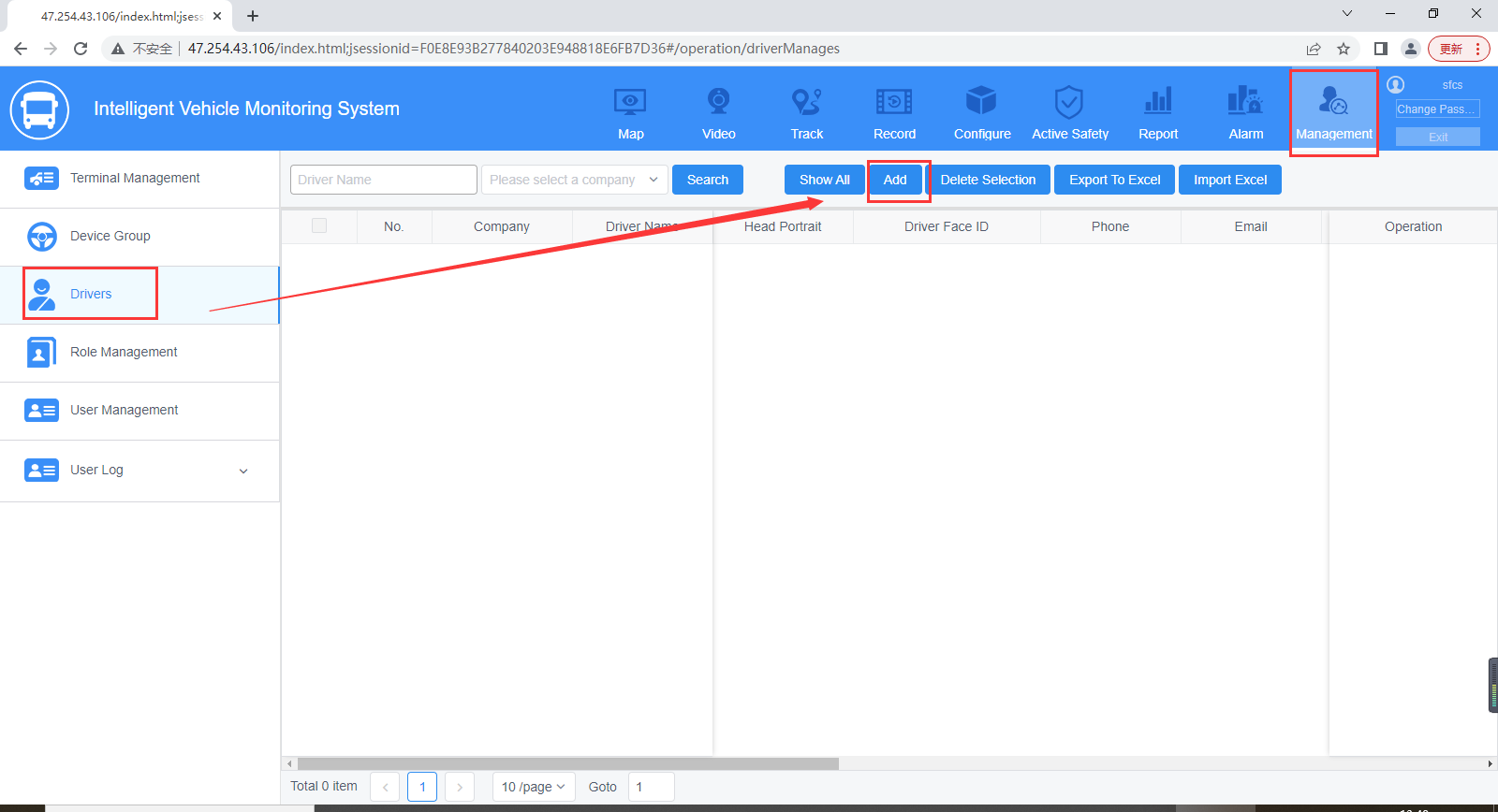
3. Set the Driver name, Staff ID, License number, and upload the driver photo to finish add the driver.
Notice: The driver photo Width: 172~516, Height: 220~660, only support jpg, jpeg, bmp formats.
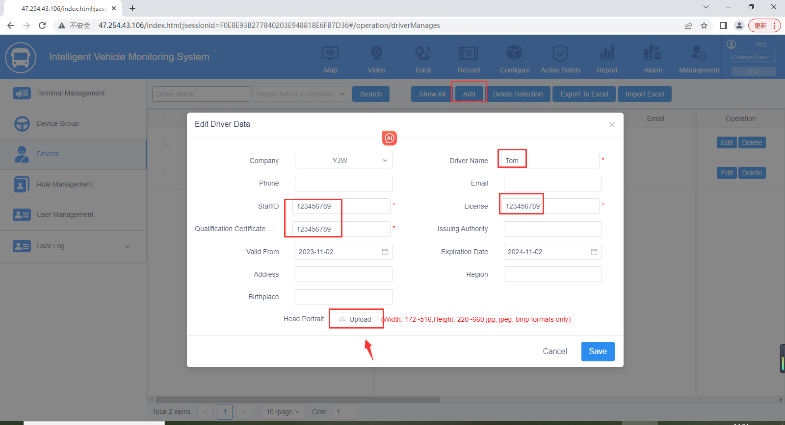
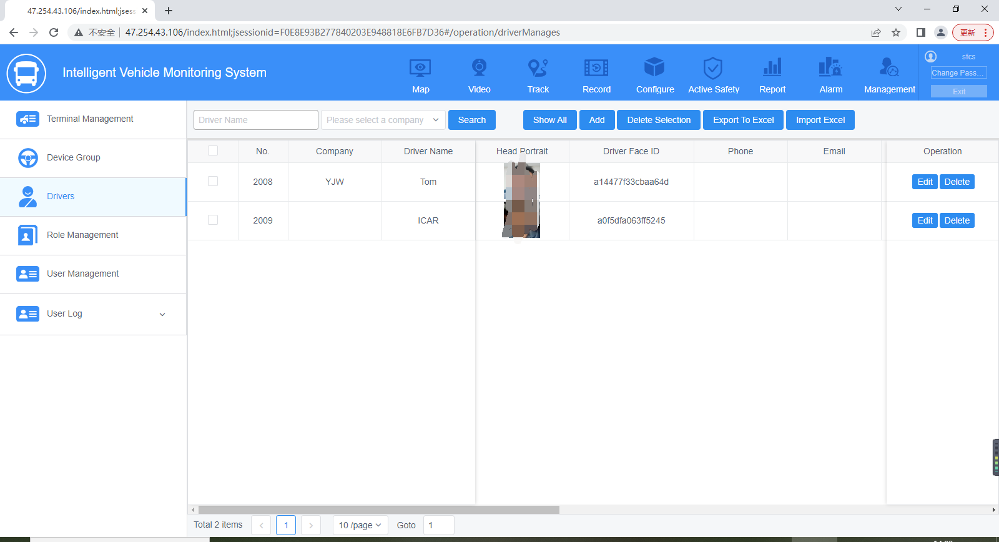
4. Login the IVMS Client, right click the device which you want to test this function, and set as below:
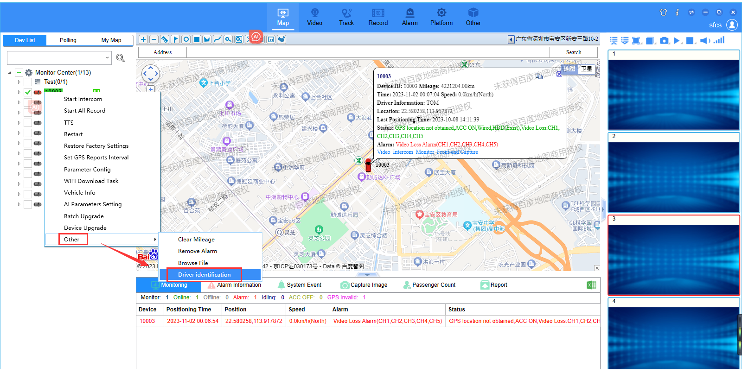
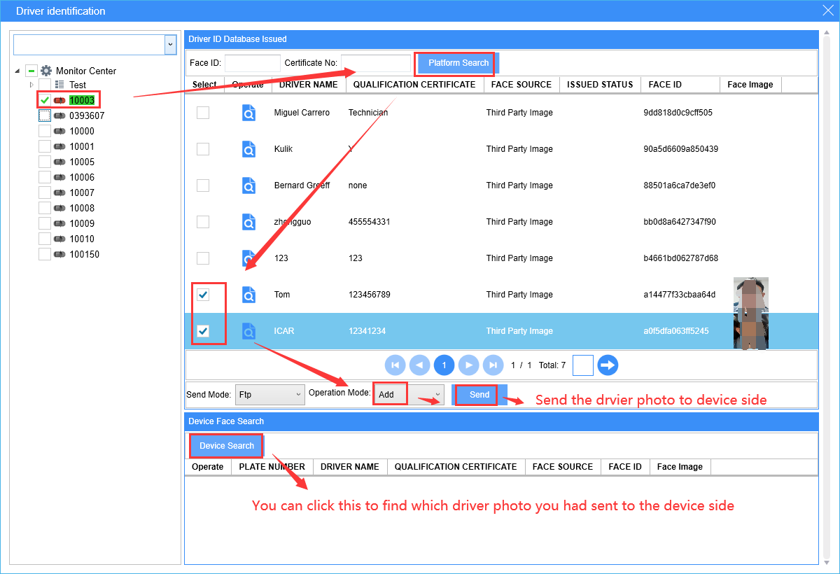
5. After finished this, then you can set the MDVR parameters, you can choose the alarm trigger way, the face similarity (usually use 70%), and the face comparison interval.
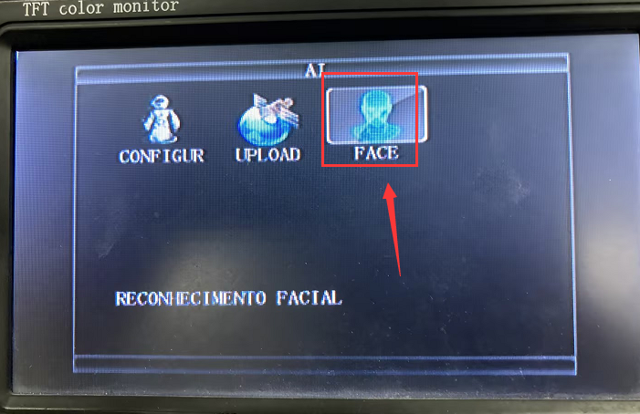
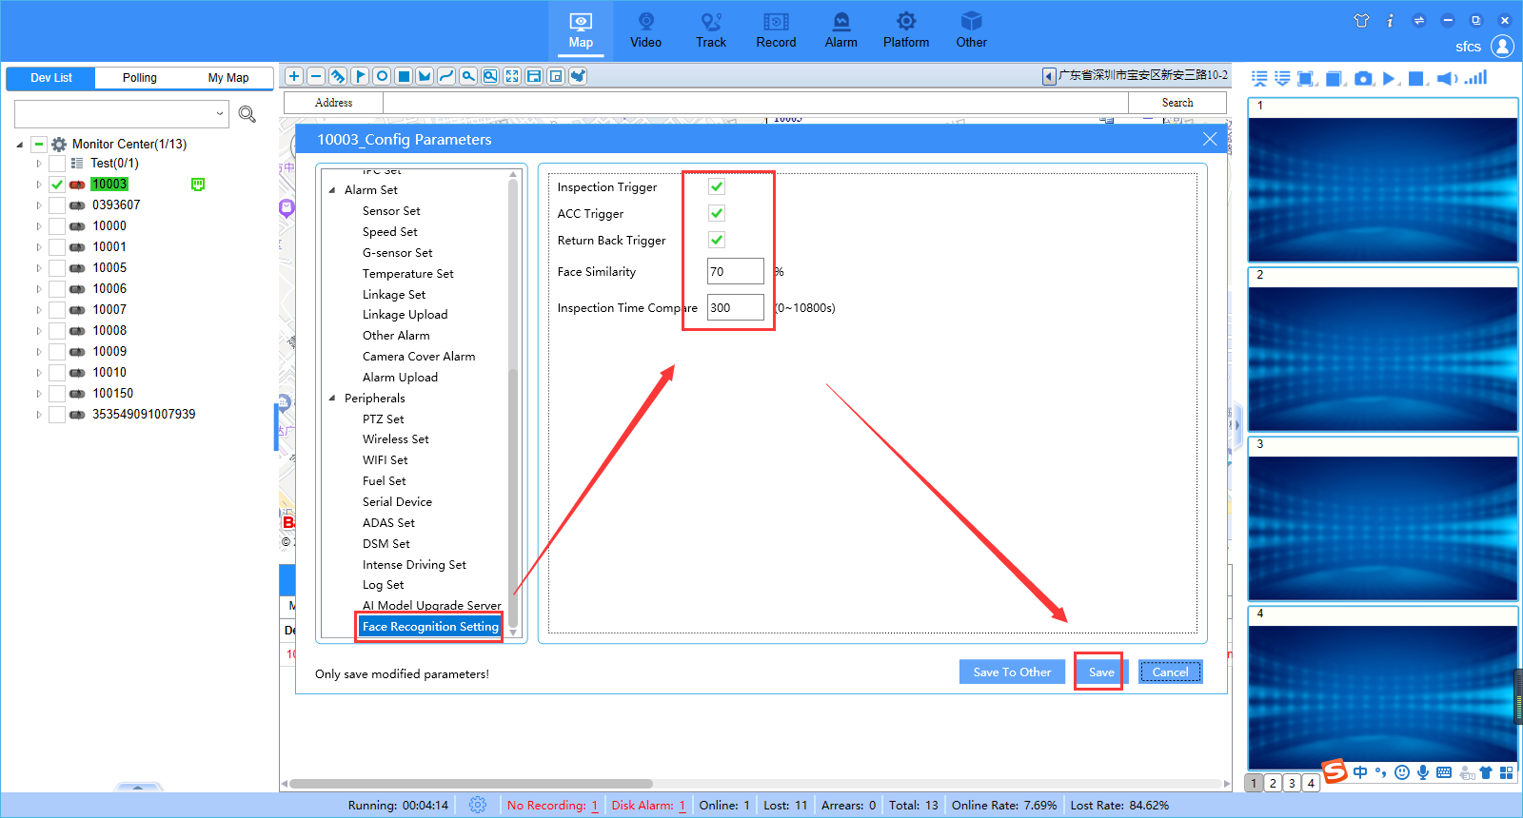
6. These are some alarms show at IVMS Client and web report side, see below:
