Batch Vehicle upgrade firmware

​Frist. Choose device and select " Batch Upgrade".

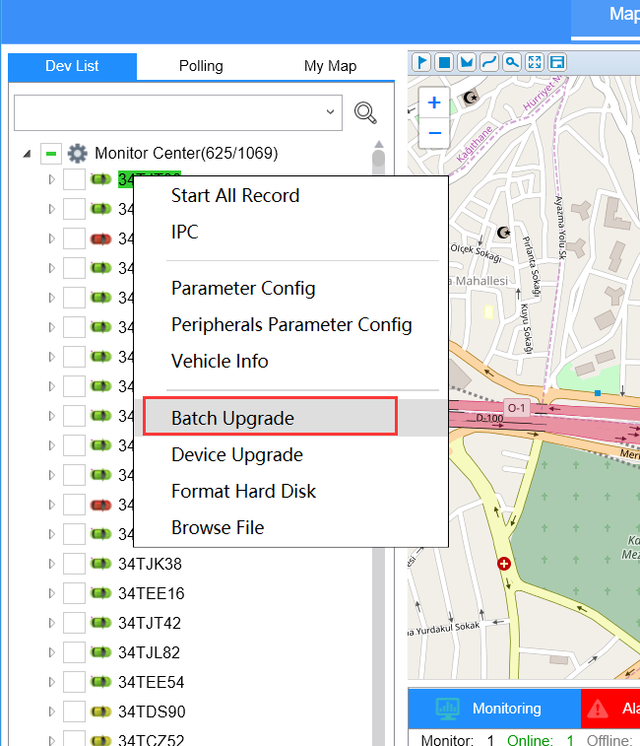

Second. Click “Upload File” to upload the firmware or MCU.
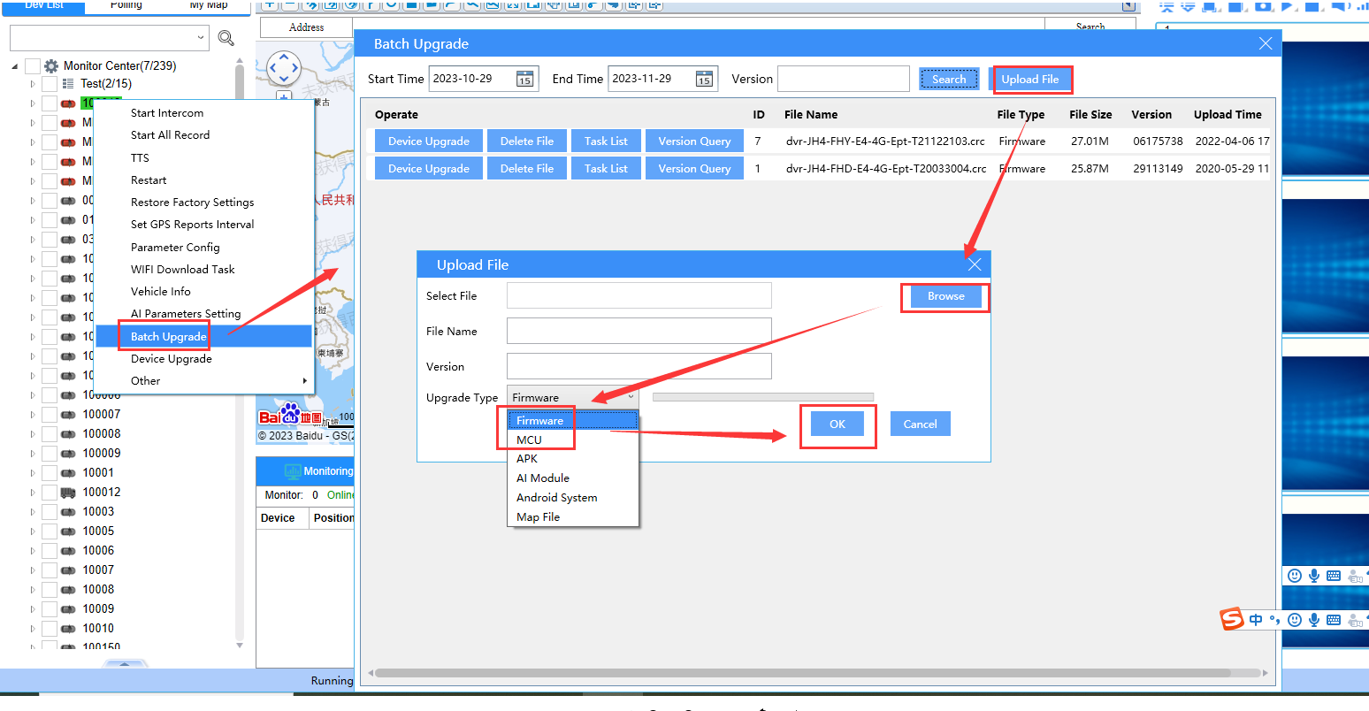
Third. After the firmware/MCU files upload success, click Search to get the firmware/MCU files, find the firmware/MCU you want to upgrade, then click Device upgrade to choose the device you want to upgrade.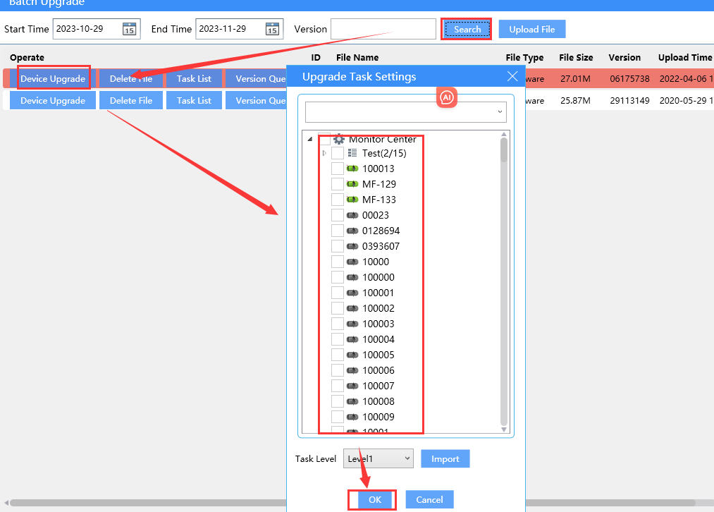

Fourth. Click " OK " and it will show you “Set batch upgrading task success”, and you can click the task list to check the device upgrade status.
