**How to cancel the Baidukey error on the web client**

1. First stop the web server.

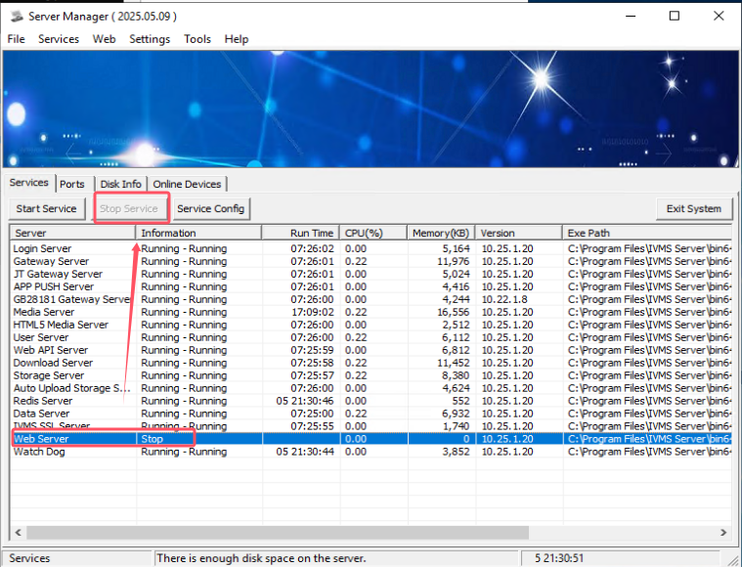

1. Open the **index.html** file, remove these two lines.

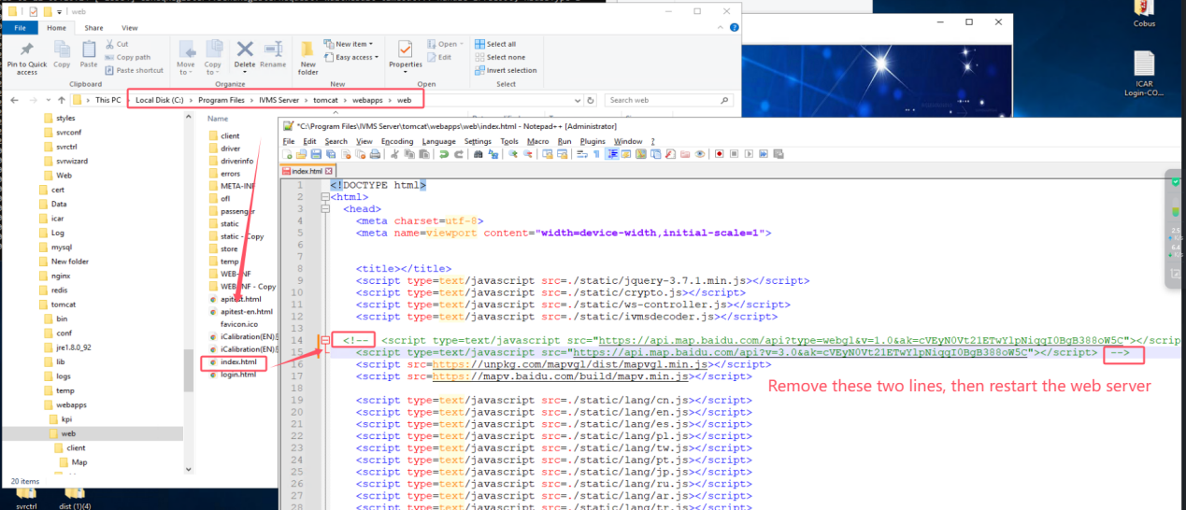

1. Restart the web server. Open the web client again and the error prompts disappear.

